NETAJI SUBHASH MAHAVIDYALAYA
UDAIPUR, GOMATI TRIPURA

2022 bisini Kokborok Sal Palaijakmani kokthum:
Kokborok Kok wngkha Tripura hasteni borok dophani kok. O kokborok kok 1979 bisi January 19th salmario Tripura hasteni kok hinwi Gosijakha. Aphuruni simi bisi brumno 19th January salno Kokborok Kok haphangbai gosijakma sal hinwi palaijagwi phai tongo. Takwlai 2022 bisiobo Netaji Subhash Mahavidyalaya Udaipur , Gomati Tripura o Kokborok salno kahamkheno palaijakkha. Tamokhe Jora hamyani phero kwlaimabai 19th January wngyawi 20th January 2022 salmario online web webinar ni bisingtwi kahamkheno palaijakkha.
O Pandao webinarni bisingtwi chwngbai Naruwai motom wngwi kwrwngkha Borom gwnang Bikashrai Debbarma,(Rwchap kwrwng tei swikwrwng). Kasku wngwi manjakkha Borom gwnang Sudhan Debnath, Principal in-charge,NSM. Pandani tangphang wngkha Borom gwnangjwk Patriot Debbarma, Asstt. Prof. English Department, HOD in-charge Department of Kokborok. Abono karwi Pandano mwchangrithani chubanairok wngkha Mani Debbarma(Guest Lecturer,NSM), Pranay Debbarma (Guest Lecturer,NSM), tei Ajit Kishore Jamatia (Guest Lecturer,NSM), O pandani Webinaro online ni bisingtwi bebagwi khorok 562 ahai manjakkha.
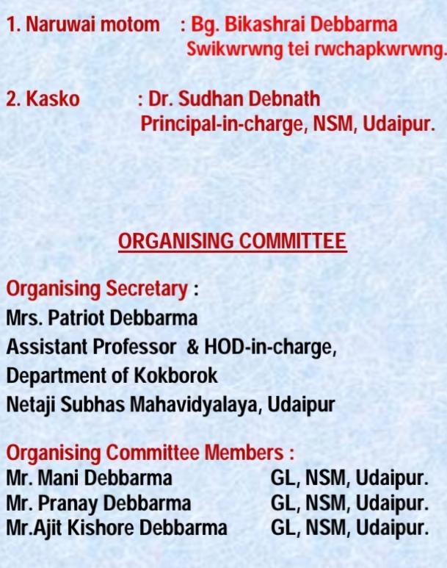
Panda khwlaijakmani bwtang:

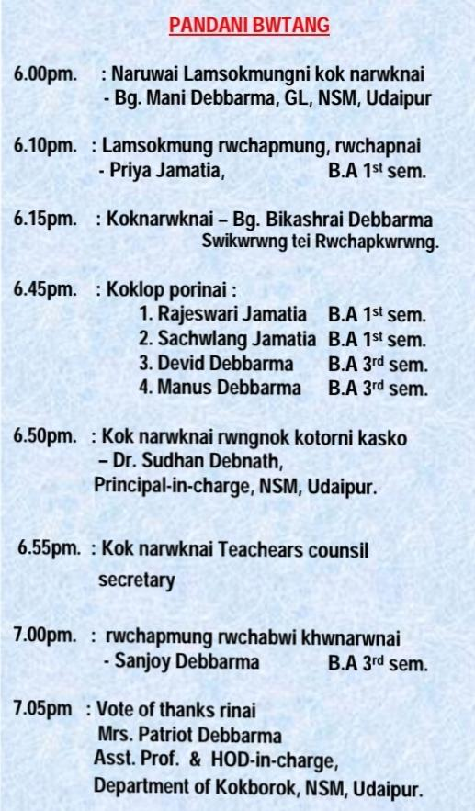

Webinar Pandani mangpili
