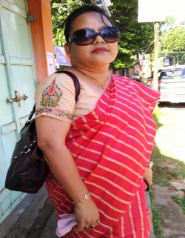
Dr. KARNIKA SINHA
(HEAD OF THE DEPARTMENT)
ASSISTANT PROFESSOR
Phone no:9774602737
Email:karnikasinha70@gmail.com
M.A. (EDUCATION), PhD, Adult Education (PG Diploma)
Educational qualification/Seminar/Webinar/
- Publications Participated and presented a paper “ Impact of CBCS system : A study …colleges in Tripura” at the national seminar on ‘Quality enhancement in Higher Education in Northeast India: challenges and opportunities’ organized by IQAC Govt. degree college; Dharmanagar on 26/02/2017
- Participation in training program titled “ Information technology and digital services” at NSM ,Udaipur on 15/11/2018-06/12/2018
- Performed the duty of jury member of Dist. Level Youth Parliament on 24/01/2019 at NSM, Udaipur
- Participated and presented a paper Education Policy: conditions, exclusion and inclusion from the perspective of Indigenous communities in Northeast India at the national seminar on ‘Transitional aspects of Indigenous people of Northeast India: Contemporary issue on sustainability’ at NSM, Udaipur on 12/01/2020
- Participated and presented a paper Significance of selected motor fitness components in selected indigenous games of Tripura : A theoretical approach at the national seminar on “ Promotion of indigenous games : Issue and challenges with special reference to Tripura at MMDC Sabroom on 07/11/2019
- Participation on MINDFUL , a mind control training seminar by Panacea, at Muktadhara Auditorium , Agartala on 24/11/2019
- Participated and presented a paper Changing perceptions about Indigenous women in selected literatures of Kokborok at the national seminar on “Transitional aspects of indigenous people of Northeast India : contemporary issues on sustainability” at NSM, Udaipur on 12/01/2020
Participated in the national seminar organized by Dept. of Chemistry , NSM , Udaipur Udaipur from 27th-28th November 2015

