Faculty Profile
Name: Sri Prasenjit Paul 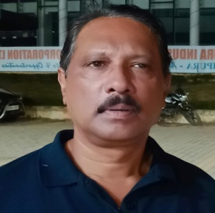
Designation: Associate Professor & Head
E-mail: ap.prasenjit02@gmail.com
Date of Joining in Service: 12.4.2002
Qualifications: M.Com, M.Phil.

Subject: Commerce
Specialization: Management, Marketing, HRM.
Publications:
Paul, Prasenjit (2015). A Study on Socio-Economic Status of People Residing in Rural Areas of Tripura. Interdisciplinary Journal of Contemporary Research, Vol.2, No.5, Pp137-40.
Other Responsibilities: Present Drawing and Disbursement Officer (DDO)

