DEPARTMENT OF EDUCATION
NETAJI SUBHASH MAHAVIDYALAYA, UDAIPUR, GOMATI TRIPURA
DEPARTMENT FACULTIES:

Sl. No. | Photo | Name and Designation | Educational qualification/Seminar/Webinar/  Publications | Contact details
1. | 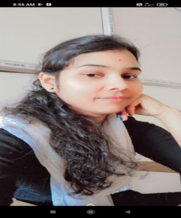 | RUMA MODAK  GUEST TEACHER | M.A.(EDUCATION), B.Ed. | Phone no:8014973044  Email: rumamodak05@gmail.com

