List of Faunal Diversity of Netaji Subhas Mahavidyalaya
Period- August, 2021(day time)
Dr. NupurDatta, HOD in charge, Department of Zoology, NSM
Data and photography: Aditya Karmakar, Student of 5th Sem, Zoology Honours, NSM
Technical support: Sukanta Biswas, student of 5th sem, Zoology Honours, NSM

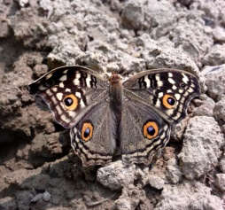
- Chinese Lemon Pansy
Junonia lemonias lemonias (Linnaeus,1758)
Family: Nymphalidae
Habitat: Open Grassland
Collection period: Morning

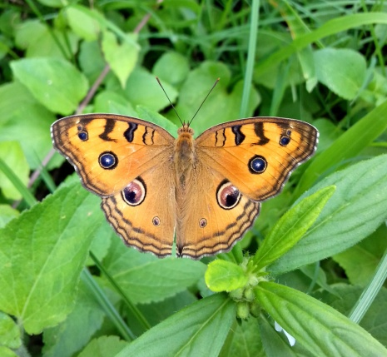

- Oriental Peacock Pansy
Junonia almana almana (Linnaeus,1758)
Family: Nymphalidae
Habitat: Open Grassland
Collection period: Morning

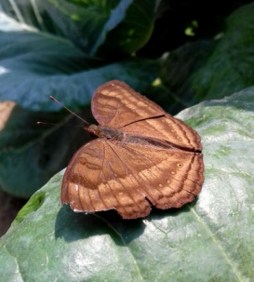

- Oriental Chocolate Pansy
Junonia iphita iphita (Cramer,1779)
Family: Nymphalidae
Habitat: Open Grassland
Collection period: Morning

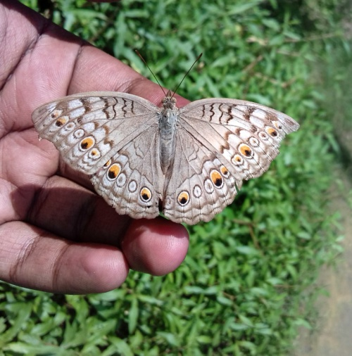
- Oriental Grey Pansy
Junonia atlitesatlites(Linnaeus,1763)
Family: Nymphalidae
Habitat: Open Grassland
Collection Period: Morning

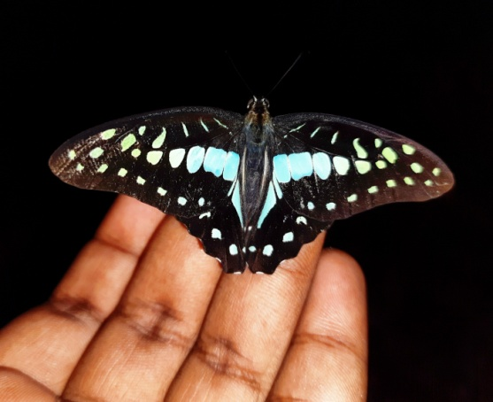
- Himalayan Common Jay
Graphiumdosondoson(Page & Treadaway,2014)
Family: Papilionidae
Habitat:Semi evergreen forest
Collection Period: Noon

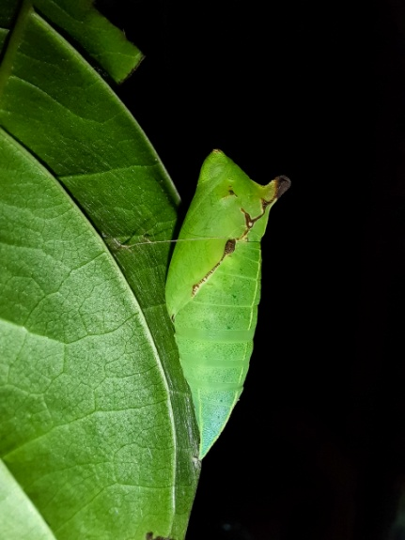

- Oriental Tailed Jay
Graphium Agamemnon agamemnon (Linnaeus,1758)
Family: Papilionidae
Habitat: Semi evergreen forest
Collection period: Noon

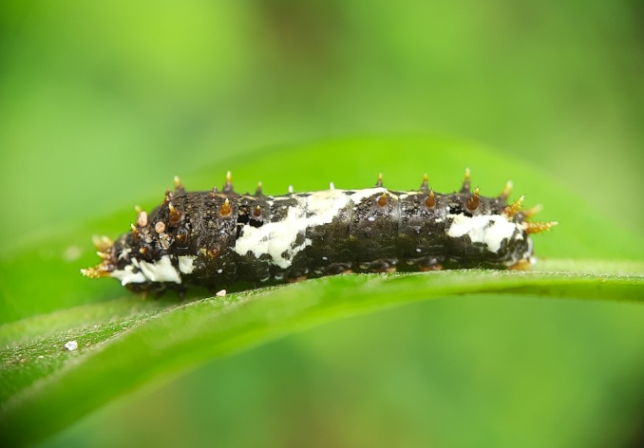
- Northern Lime Swallowtail
Papilio demoleus demoleus(Linnaeus, 1758)
Family: Papilionidae
Habitat: Garden
Collection period: Noon

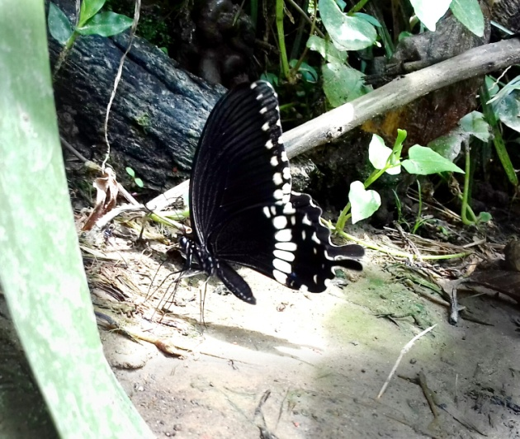

- Indian Common Mormon
Papilio polytes romulus(Cramer,1775)
Family: Papilionidae
Habitat: Garden
Collection period: Morning

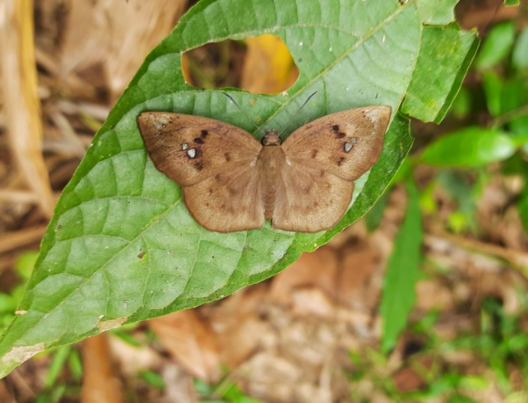
- Himalayan Common Snow Flat
Tagiades japetus ravi (Moore,1866)
Family: Hesperiidae
Habitat: Semi evergreen forest
Collection time: Noon

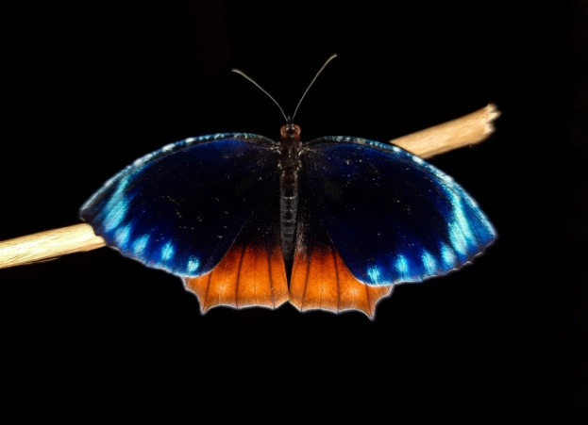
- Himalayan Common Palmfly
Elymnas hypermnestra undularis(Drury,1773)
Family: Nymphalidae
Habitat: Open Land
Collection time:Morning,noon

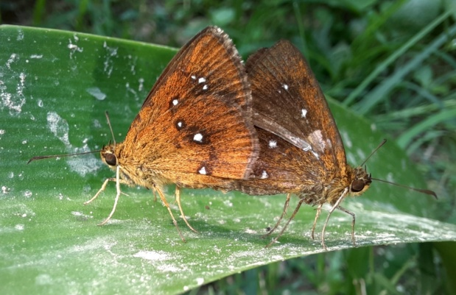
- Eastern Chestnut Bob
Iambrix salsala salsala(Moore,1866)
Family: Hesperiidae
Habitat:Garden,Semi evergreen forest
Collection time: Morning

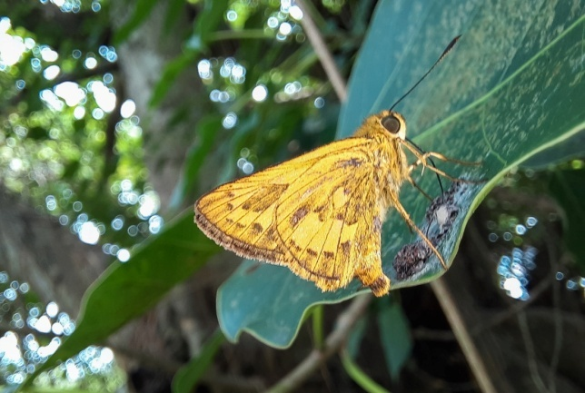
- Dart sp.
Telicota sp.(Fabricius, 1775)
Family: Hesperiidae
Habitat: Forest area
Collection time: Noon

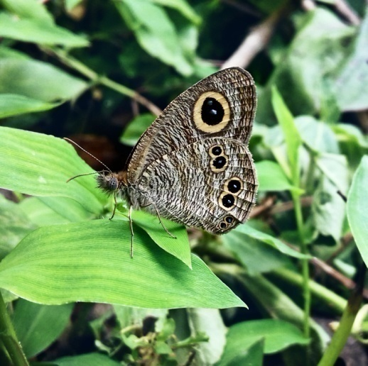
- Himalayan Common Five-Ring
Ypthima baldus baldus(Fabricius, 1775)
Family: Nymphalidae
Habitat: Open grassland
Collection time: Morning

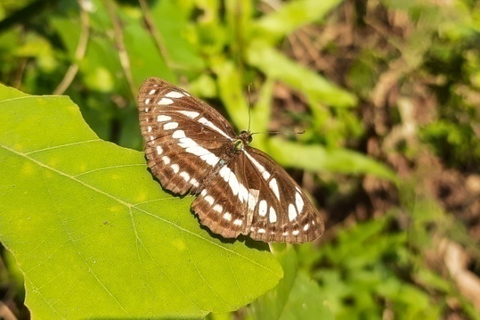
- Indian Common Sailor
Neptis hylas varmona(Moore,1872)
Family: Nymphalidae
Habitat:Open grassland
Collection time: Noon

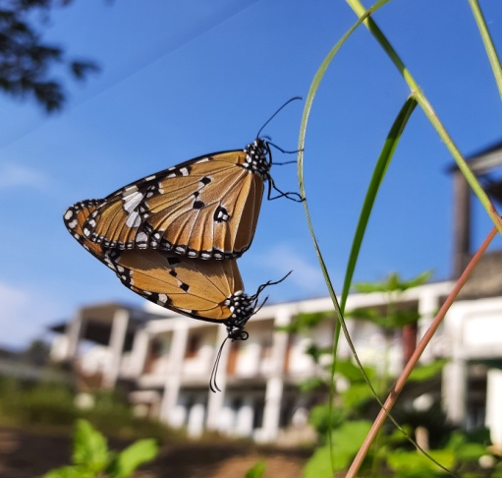
- Oriental Plain Tiger
Danaus chrysippus chrysippus(Linnaeus,1758)
Family: Nymphalidae
Habitat: semi evergreen forest
Collection time: Morning

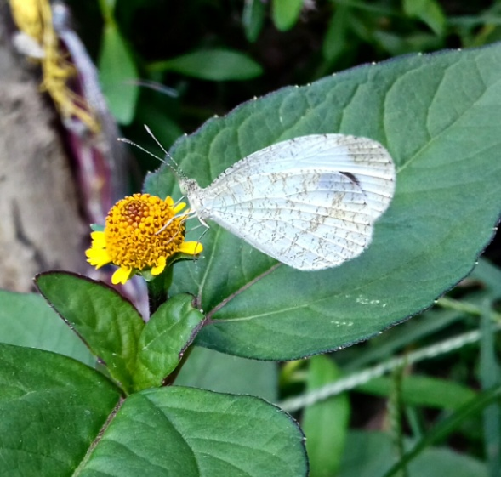
- Oriental Psyche
Leptosia nina nina(Fabricius, 1793)
Family: Pieridae
Habitat:Humanhabitat,shady areas
Collection Time: Morning

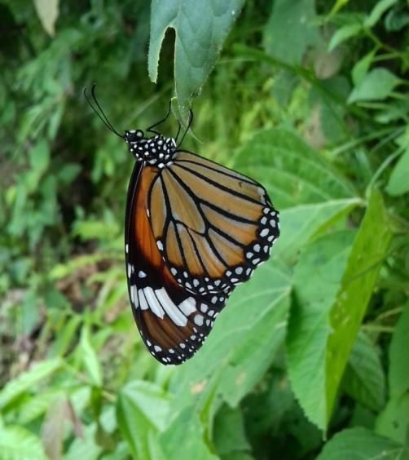
- Oriental Striped Tiger
Danaus genutia genutia(Cramer,1779)
Family: Nymphalidae
Habitat: Semi evergreen forest
Collection time: Noon

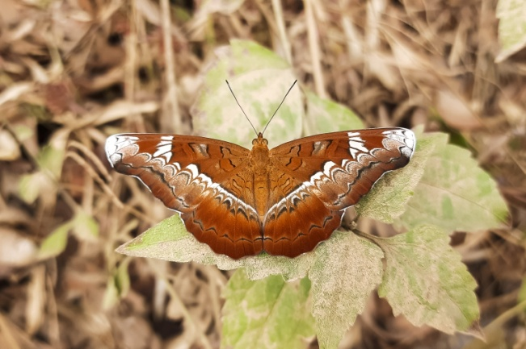
- Thai Knight
Lebadea Martha martha(Fabricius, 1787)
Family: Nymphalidae
Habitat: Semi evergreen Forest
Collection time: Noon

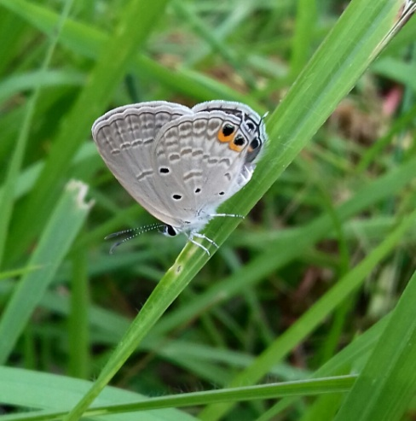
- Oriental Gram Blue
Euchrysops cnejus cnejus(Fabricius ,1798)
Family: Lycaenidae
Habitat: Open grassland
Collection Time: Morning

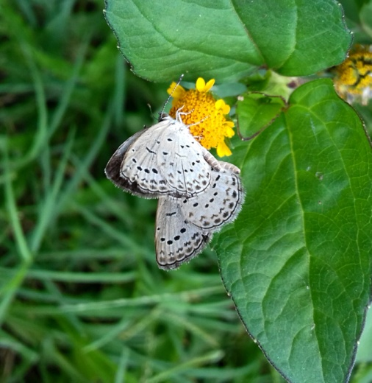

- Himalayan Pale Grass Blue
Pseudozizeeria maha maha Kollar,1844)
Family: Lycaenidae
Habitat: Open land
Collection Time: Morning

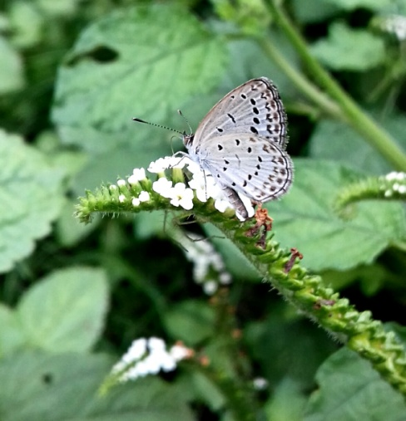

- Dark Grass Blue
Zizeeria karsandra (Moore,1865)
Family: Lycaenidae
Habitat: Open land,Grassland
Collection time: Morning

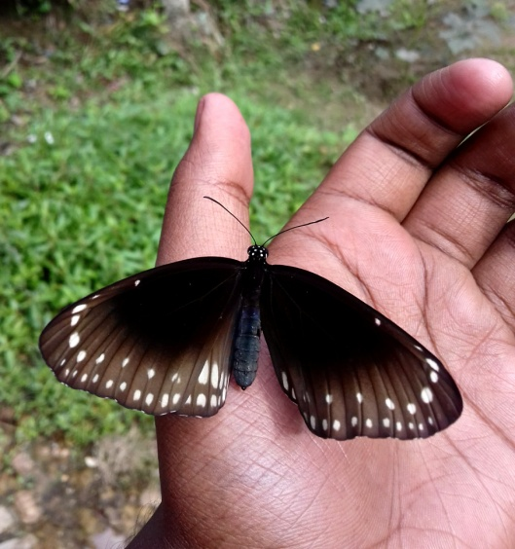
- Indian Common Crow
Euploea core core( Cramer,1780)
Family: Nymphalidae
Habitat: Semi evergreen Forest
Collection Time: Noon

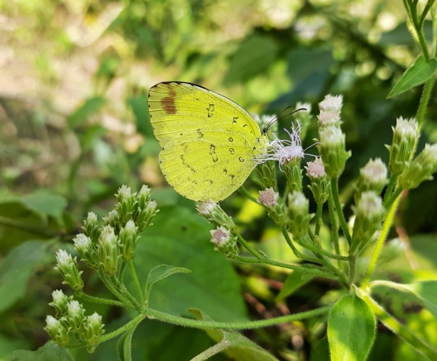
- Oriental Common Grass Yellow
Eurema hecabe hecabe(Linnaeus, 1758)
Family: Pieridae
Habitat: Open land,Sunny areas
Collection Time: Morning

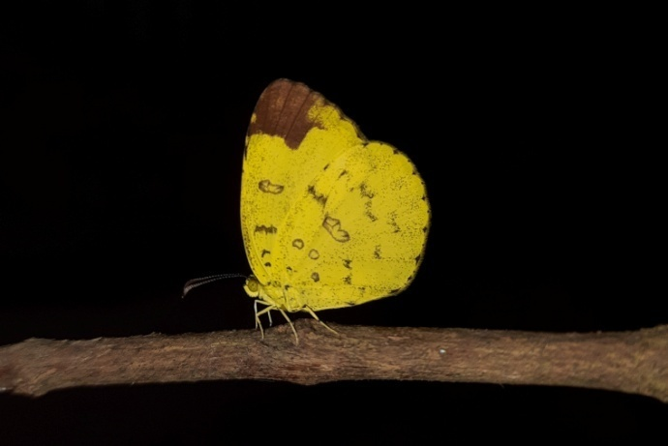

- Sylhet Three-Spot Grass Yellow
Eurema blanda silhetana( Wallace, 1867)
Family: Pieridae
Habitat: Open Land
Collection Time: Noon

- Oriental Great Egg fly
Hypolimnas bolina jacintha(Drury,1773)
Family: Nymphalidae
Habitat: Semi evergreen Forests,Human habitat
Collection time: Noon

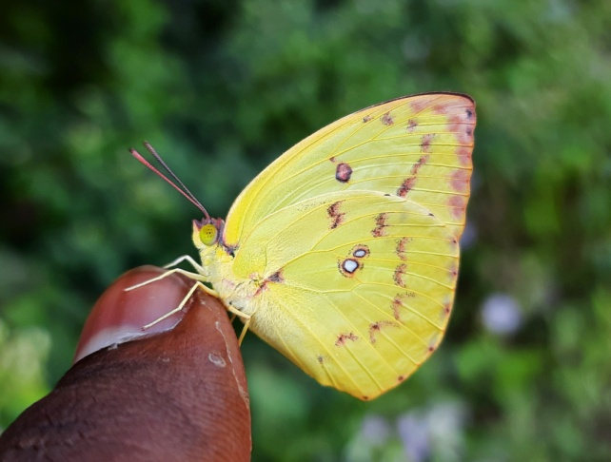

- Oriental Lemon Emigrant
Catopsilia Pomona pomona(Fabricius, 1775)
Family: Pieridae
Habitat: Open land,Grassland
Collection Time: Noon

- Oriental Mottled Emigrant
Catopsilia pyranthe pyranthe(Linnaeus, 1758)
Family: Pieridae
Habitat: Open land
Collection time: Noon

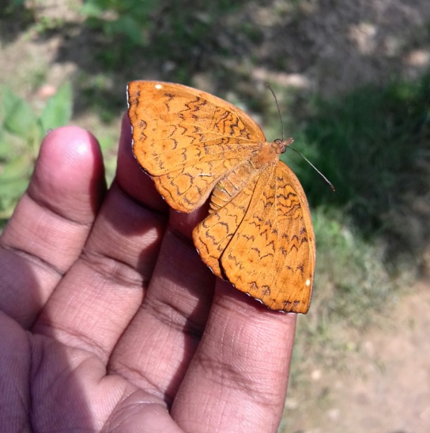
- Intricate Common Castor
Ariadne merione tapestrina(Moore,1884)
Family : Nymphalidae
Habitat: Open land
Collection Time: Noon

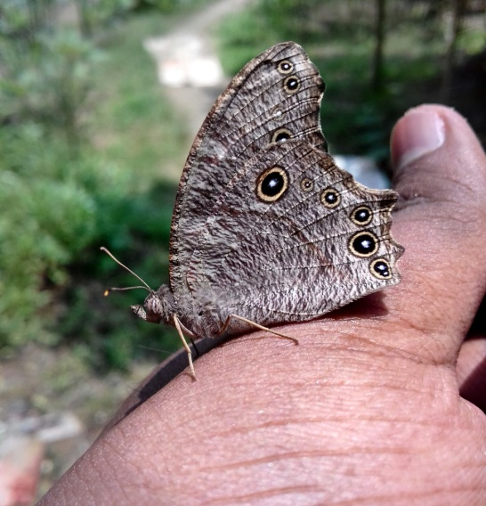

- Oriental Common Evening Brown
Melanitis leda leda(Linnaeus, 1758)
Family: Nymphalidae
Habitat: Rotten Stuffs,Shady wet areas
Collection time: Evening

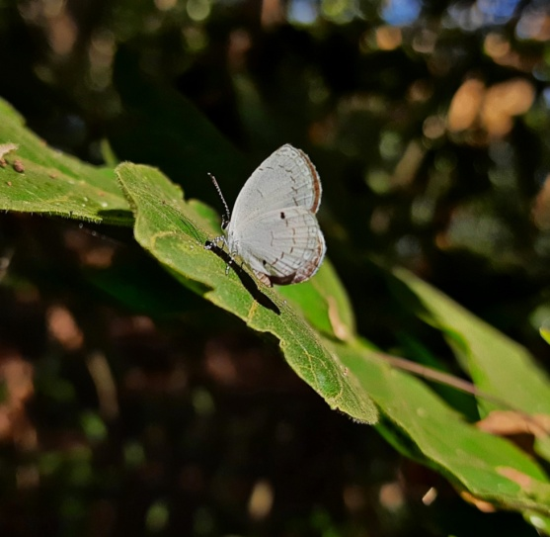

- Myanmar Common Quaker
Neopithecops zalmora zalmora(Butler,1870)
Family: Lycaenidae
Habitat: Semi evergreen forest
Collection Time: Noon

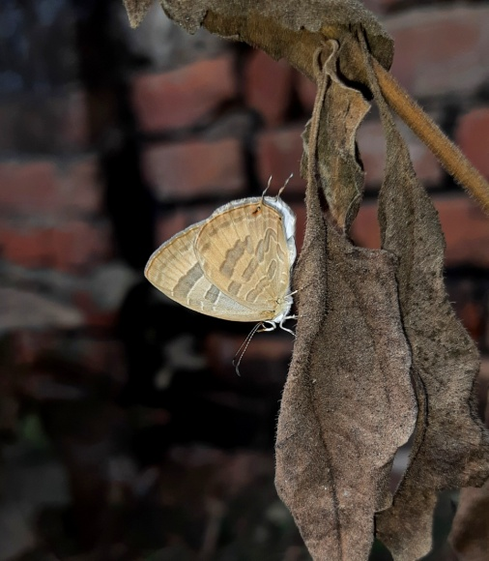
- Oriental Common Cerulean
Jamides celeno celeno(Cramer,1775)
Family: Lycaenidae
Habitat:openland,Grassland
Collection Time: Morning

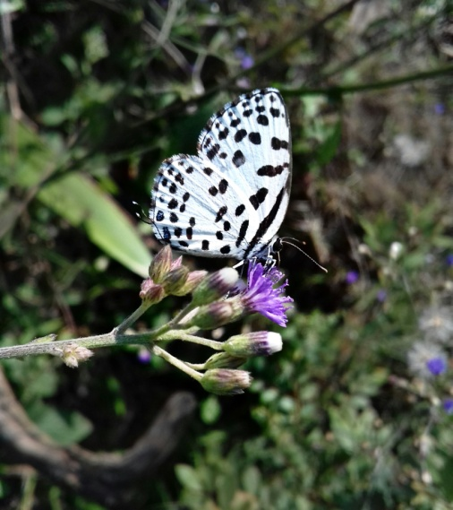

- Continental Common Pierrot
Castaliusrosimonrosimon(Fabricius, 1775)
Family: Lycaenidae
Habitat: Open vegetation
Collection time: Morning

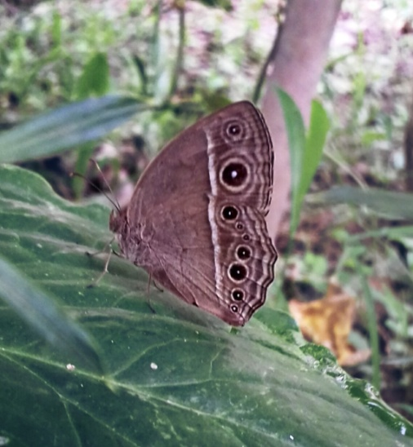

- Chinese Dark-Branded Bushbrown
Mycalesismineusmineus(Linnaeus,1758)
Family: Nymphalidae
Habitat: Shady areas,scrubs
Collection Time: Evening

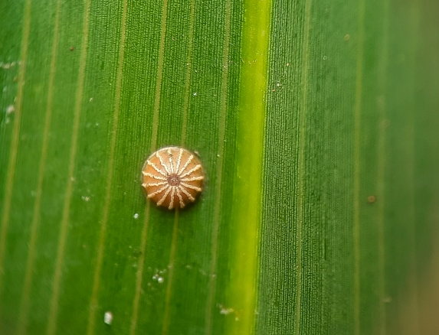
- Indian Palm Bob
Suastus gremius gremius(Fabricius, 1798)
Family: Hesperiidae
Habitat: Clear lands,bushes
Collection Time: Morning

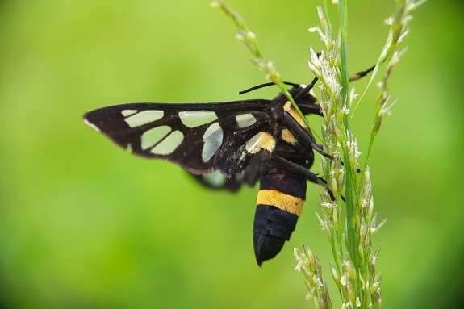
- Wasp moth
Amata sperbius(Fabricius,1787)
Family: Erebidae
Tribe: Syntomini
Habitat: Grassland,Open land
Collection time: Noon

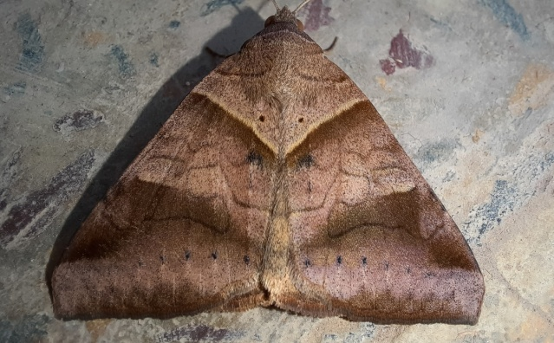

- Brown Striped Semilooper
Moci sundata( Fabricius,1775)
Family: Erebidae
Habitat: Human habitat
Collection Time: Morning

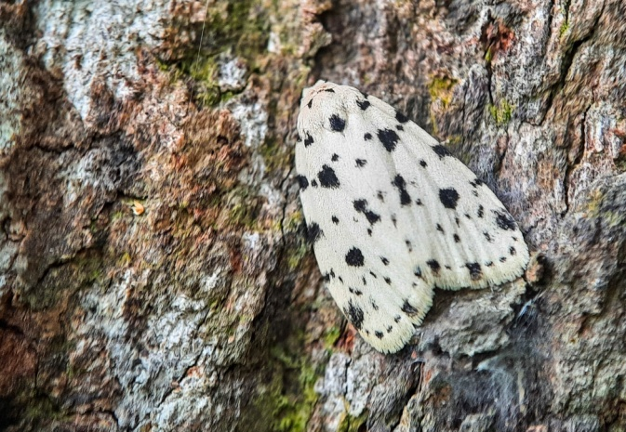
- Aemenecf. Taprobenis
Family: Erebidae
Habitat: In big tree bark
Collection time: Noon

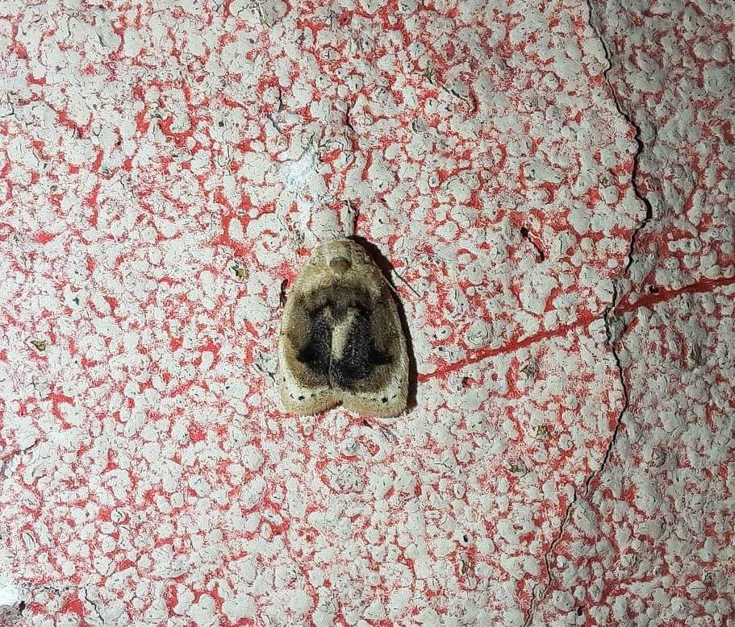

- Narosodescf.punctana
Family: Erebidae
Habitat: Tree trunk
Collection Time: Morning

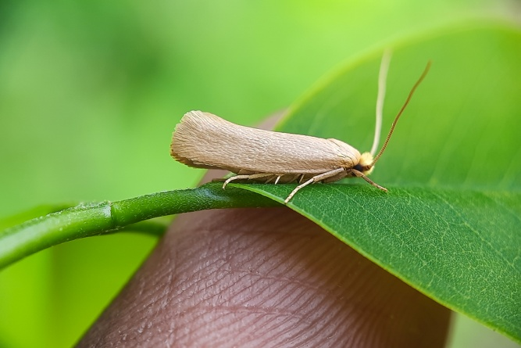

- Edosa sp.
Family: Tineidae
Habitat: Bushes
Collection Time: Noon

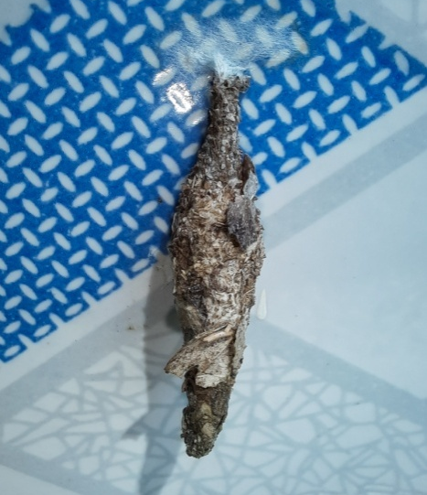
- Mahasena
Family: Erebidae
Habitat: Human habitat
Collection Time: Noon

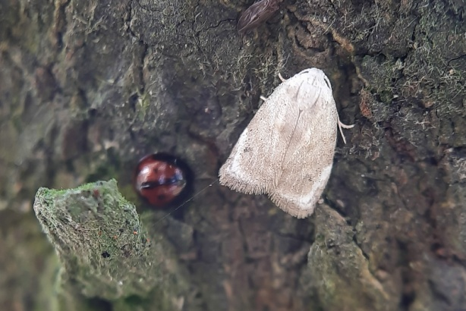

- Narosodes sp.
Family: Erebidae
Habitat: Human habitat
Collection time: Morning

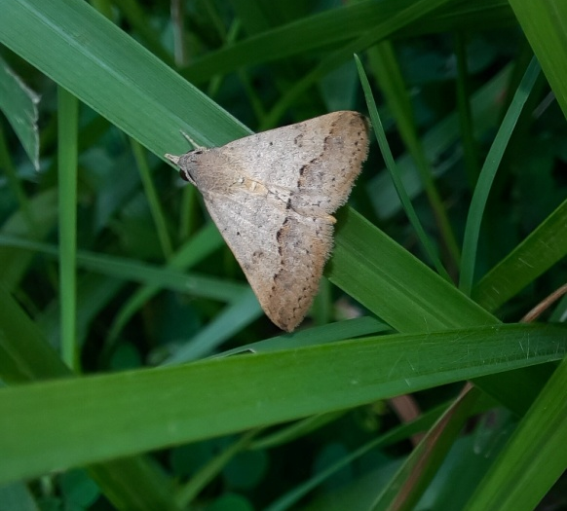

- Gesonia obeditalis(Walker,1859)
Family: Noctuidae
Habitat : Grassland
Collection time: Noon

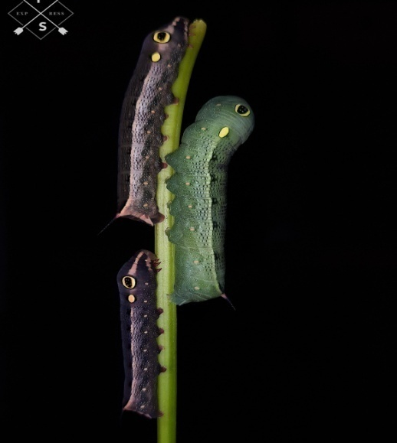
- Fruit Piercing Moth
Eudocimahypermnestra(Cramer, 1780)
Family: Erebidae
Habitat: bushes and scrubs
Collection Time: Morning

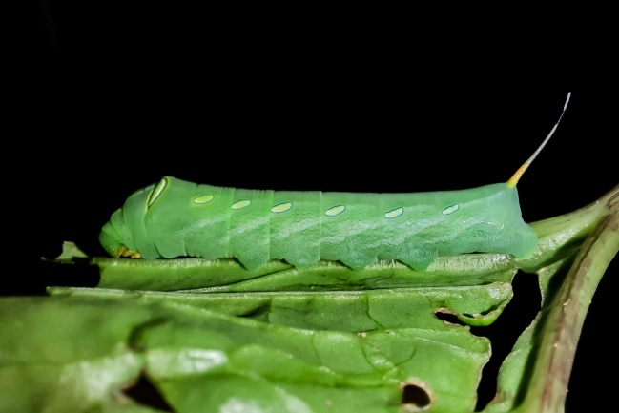

- Green Pergesa Hawkmoth
Pergesa acteus(Cramer,1779)
Family: Sphingidae
Habitat: Bushes
Collection Time: Morning

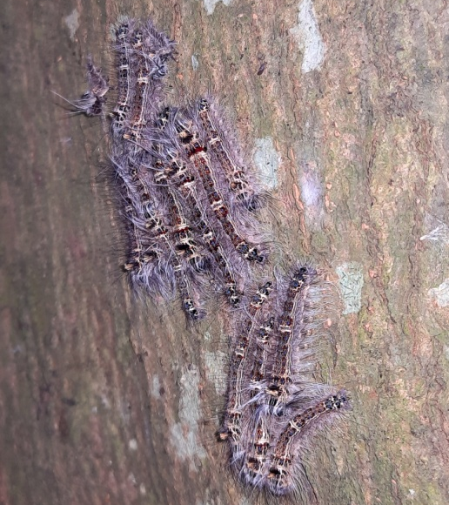

- Lappet Moth
Family: Lasiocampidae
Habitat: Tree trunk,human habitat
Collection time: Noon

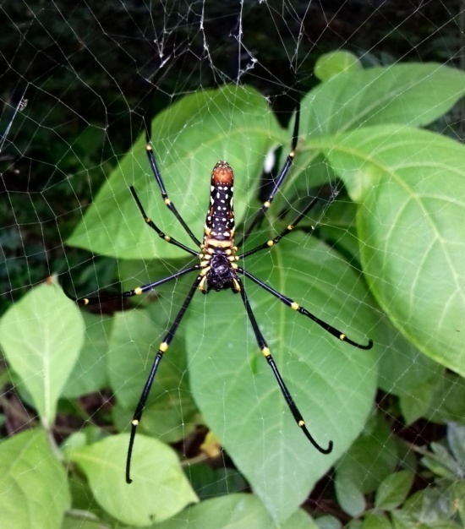
- Golden Orb Web Spider
Nephilapilipes(Fabricius, 1793)
Family: Araneidae
Habitat: Semi evergreen forests
Collection time: Noon

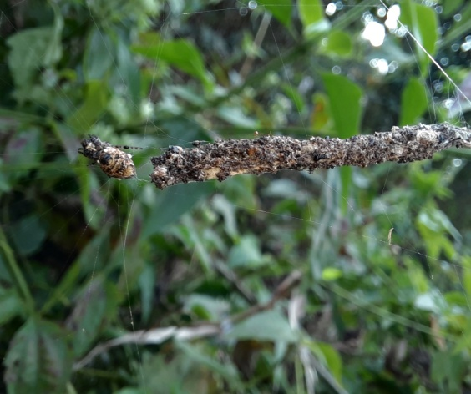

- Trashline orbweaver
Cyclosa sp.
Family: Araneidae
Habitat: Found almost everywhere
Collection time: Noon

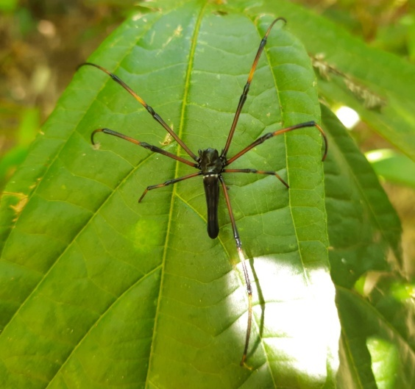

- Black Wood Spider
Nephila kuhlii (Doleschall,1859)
Family: Araneidae
Habitat: Semi evergreen forest
Collection time: Noon

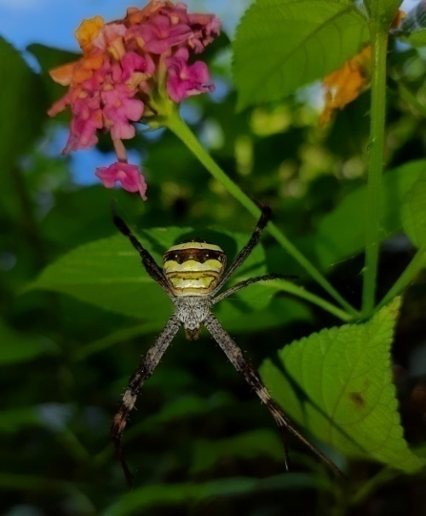
- Signature Spider
Argiope sp.
Family: Araneidae
Habitat: Semi evergreen forest,bushes
Collection time: noon

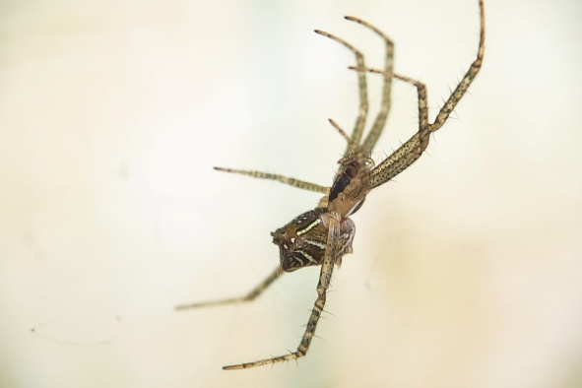

- Tent-web spider
Cyrtophoracicatrosa(Stoliczka,1869)
Family: Araneidae
Habitat: Human habitats,buildings
Collection time: Morning

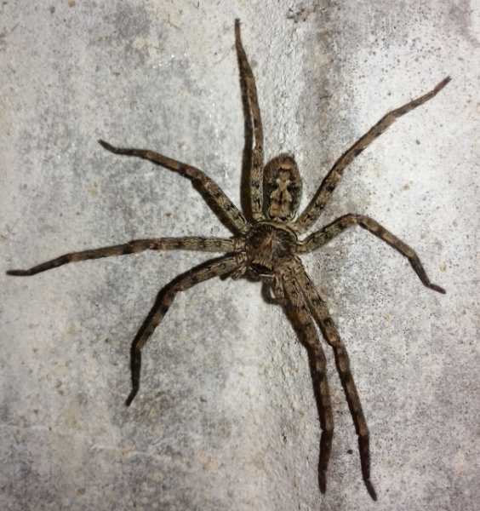

- Huntsman Spider
Heteropoda venatoria(Linnaeus, 1767)
Family: Sparassidae
Habitat: Human habitat
Collection Time: noon

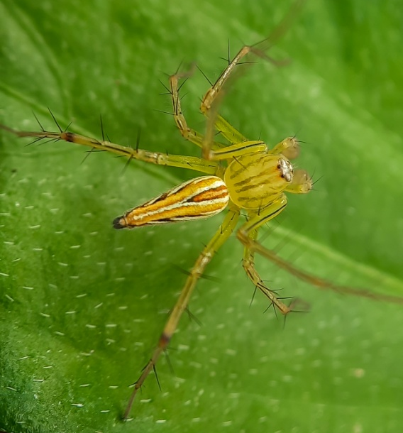
- Lynx Spider
Oxyopes sp.
Family: Oxopidae
Habitat: bushes and scrubs
Collection Time: Morning

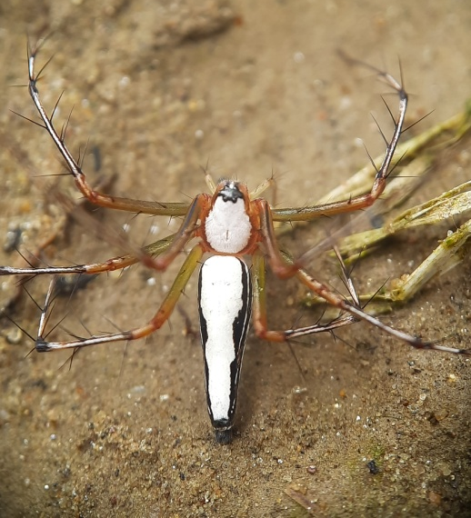

- White Lynx Spider
Oxyopes shweta(Tikader,1970)
Family:Oxopidae
Habitat: foliage and bushes
Collection time: Morning

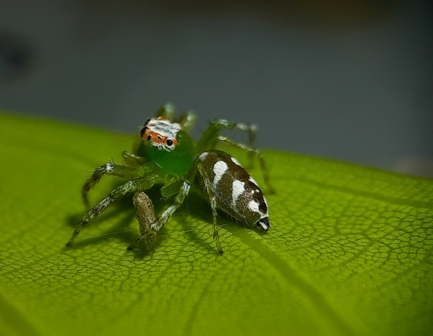

- Jumping spider
Epeus sp.
Family: Salticidae
Habitat: Foliage
Collection time: Noon

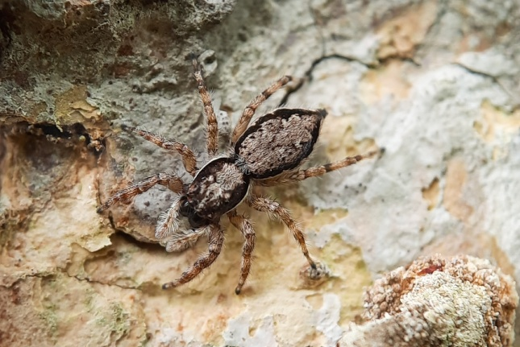
- Gray Wall Jumper
Menemerusbivittatus(Dufour,1831)
Family: Salticidae
Habitat: Human habitat
Collection Time: Noon

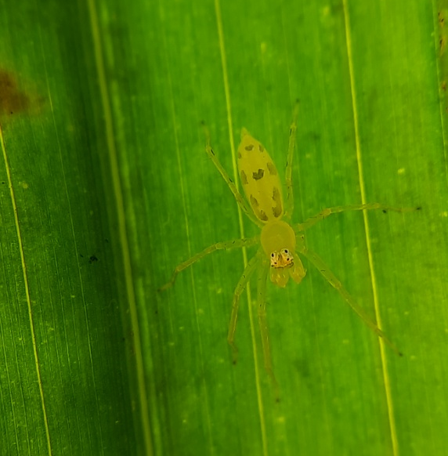

- Jumping Spider
Asemoneatenuipes(O.Pickard-Cambridge,1869)
Family: Salticidae
Habitat: Foliage(underside of leaves)
Collection Time: Morning

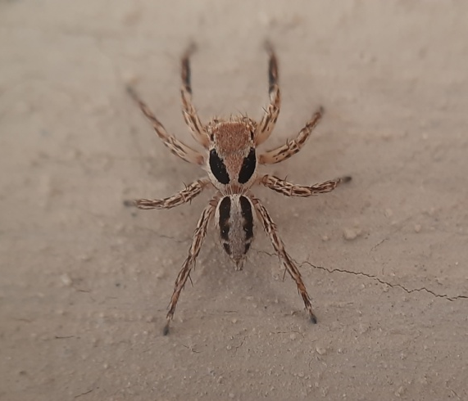

- Jumping spider
Plexippus petersi(Karsch,1878)
Family: Salticidae
Habitat: Human habitat
Collection Time: Morning

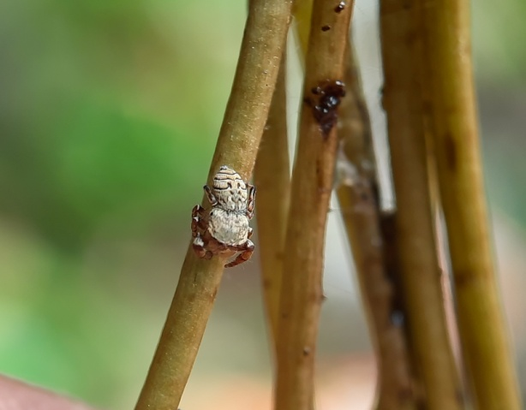
- Jumping Spider
Rhene rubrigera(Thorell,1887)
Family: Salticidae
Habitat: Foliage and stems
Collection Time: Noon

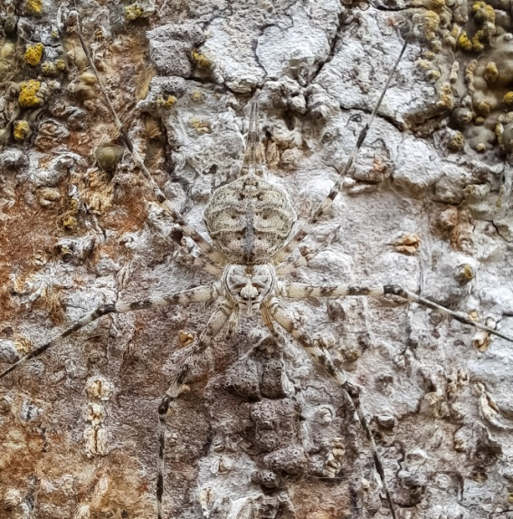

- Two Tailed Tree Spider
Hersiliasavignyi(Lucas,1836)
Family: Hesiliidae
Habitat: Tree trunk
Collection time: Morning

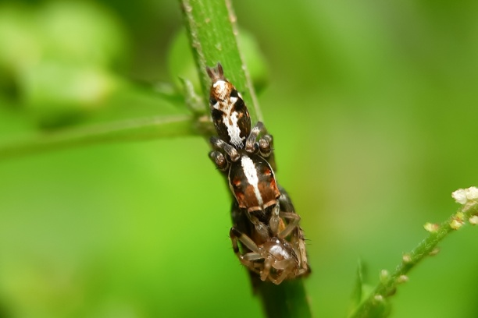

- Jumping Spider
cf. Yaginumaella sp.
Family: Salticidae
Habitat: Bush,foliage
Collection Time: Noon

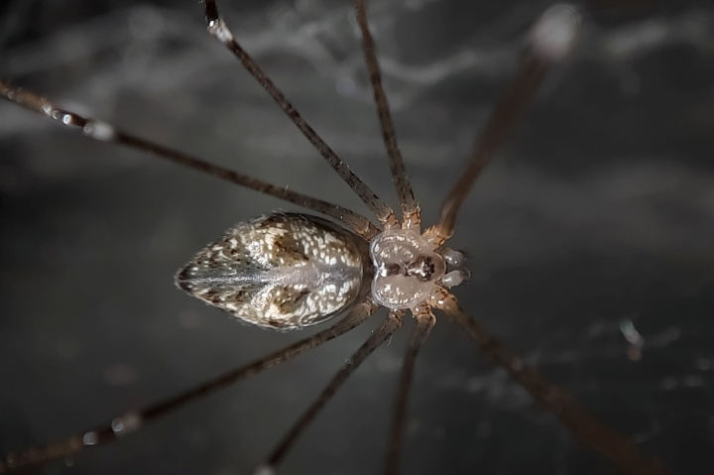
- Marbelled Cellar Spider
Crossopriza sp.
Family: Pholcidae
Habitat: Human habitat
Collection Time: Noon

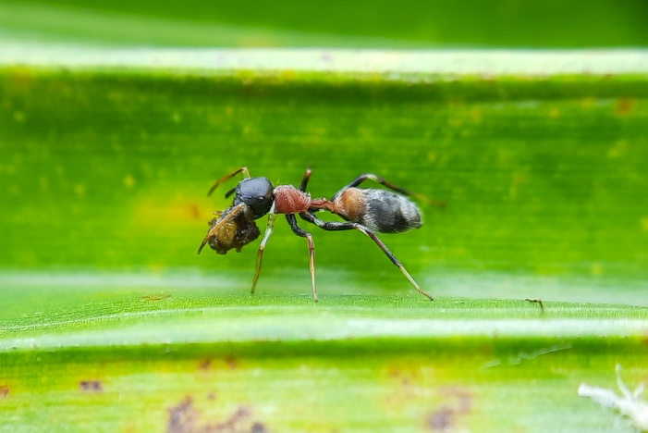

- Ant mimic spider
Myrmarachne cf. Formicaria
Family: Salticidae
Mimics- Tetraponerarufonigra
Habitat: In bushes and trees,Colony of T.rufonigra

- Weaver Ant Mimic Spider
Myrmaplataplataleoides(O.Pickard-Cambridge,1869)
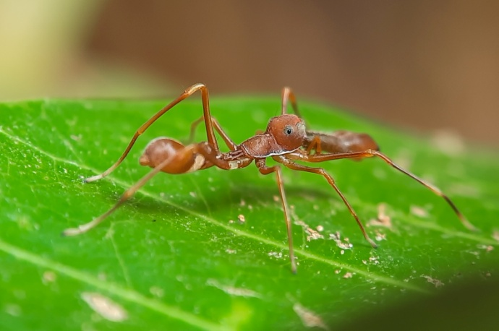
Family: Salticidae
Mimics: Oceophyllasmaragdina
Habitat: Cony of O.smaragdina,foliage
Collection Time
: Morning Jumping Spider
Carrhotusviduus(C.L.Koch,1846)
Family: Salticidae
Habitat: Bush
Collection Time: Noon

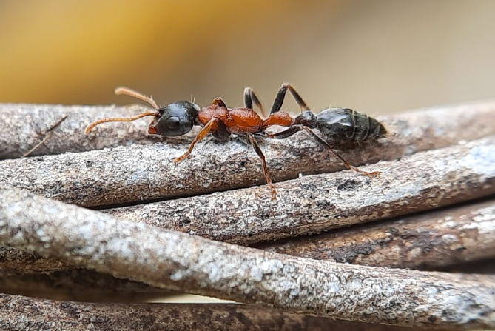
- Bi-coloured Arboreal Ant
Tetraponera rufonigra (Jerdon,1851)
Family: Formicidae
Sub family: Pseudomyrmecinae
Habitat: Trees,foliage,bushes
Collection Time: Noon

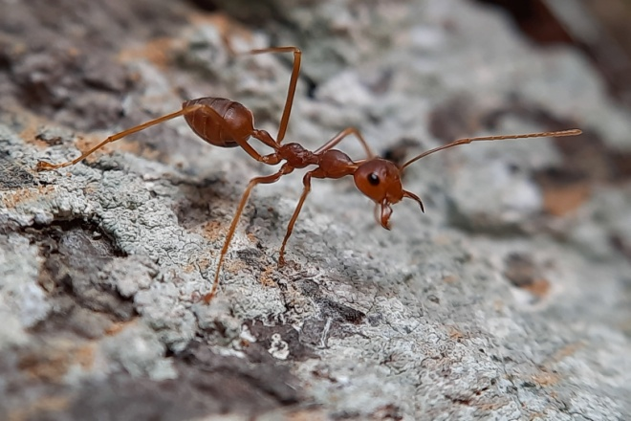

- Weaver Ant
Oceophylla smaragdina (Fabricius, 1775)
Family: Formicidae
Sub Family: Formicinae
Habitat : ground,Bushes
Collection Time: Morning

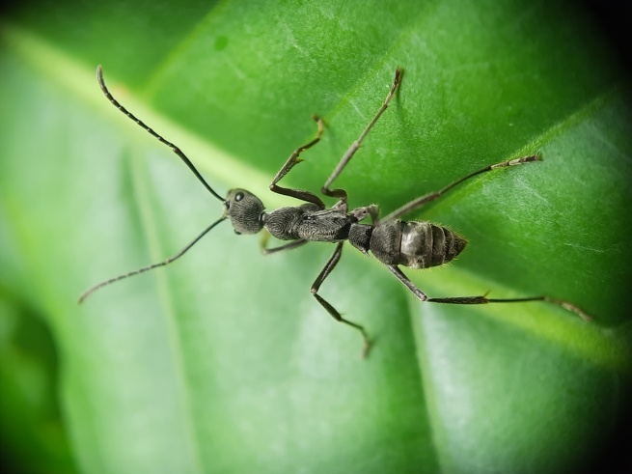

- Fingerprint Ant
Diacamma sp.
Family: Formicidae
Sub Family: Ponerinae
Habitat: Bushes
Collection Time: Noon

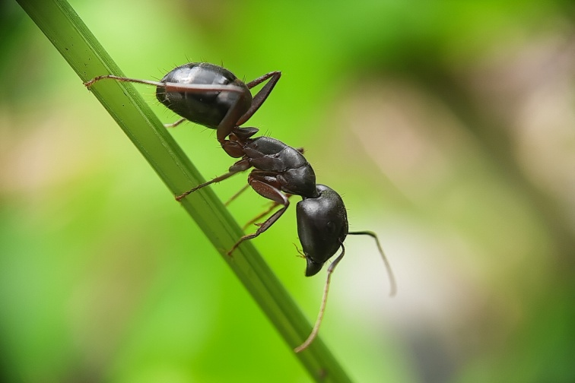
- Carpenter Ant
Camponotus compressus (Fabricius, 1787)
Family: Formicidae
Sub family: Formicinae
Habitat: Human habitat,Foliage
Collection time: Noon

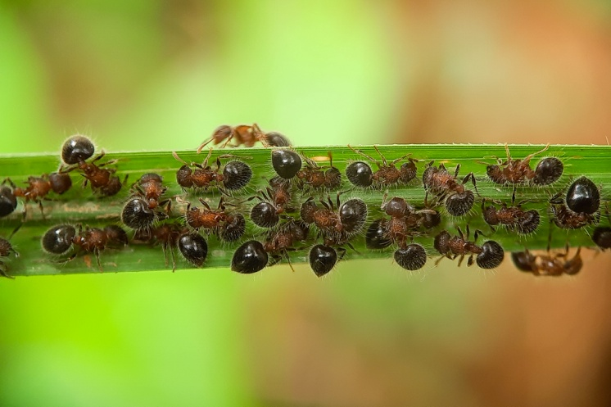

- Sheild Ant
Meranoplus bicolour (Guerin-Meneville,1844)
Family: Formicidae
Tribe: Crematogastrini
Habitat: Foliage
Collection time: Noon

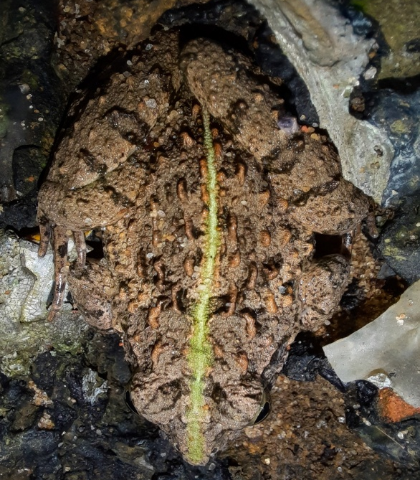

- Asian Grass Frog
Fejervarya limnocharis (Gravenhorst,1829)
Family: Dicroglossidae
Habitat: Wetlabd,Grassland
College time: Noon

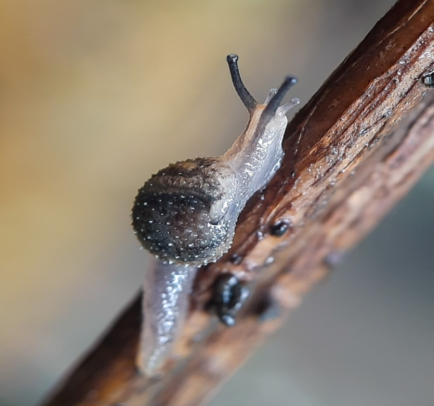
- Semi-Slug
Family: Helicarionidae
Habitat:We Rotten Tree trunk
Collection Time: Morning

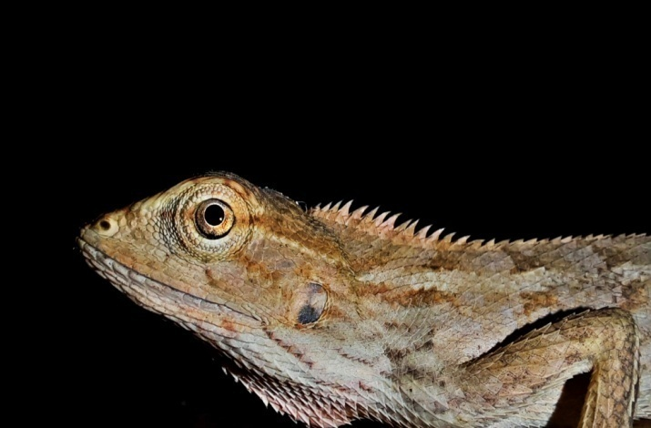

- Oriental Garden Lizard
Calotesversicolor(Daudin,1802)
Family: Aganidae
Habitat: Bushes,Foliage,Open land
Collection time: Noon

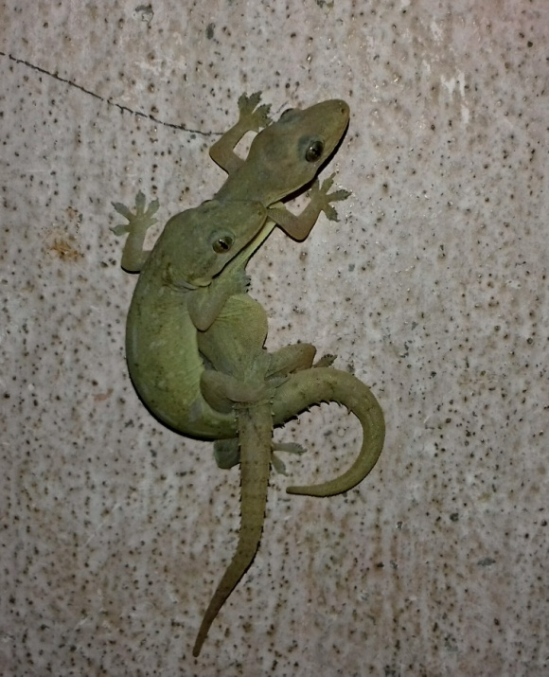

- Common House Gecko
Hemidactylus frenatus (Schlegal,1836)
Family: Gekkonidae
Habitat: Human habitat
Collection time: Noon

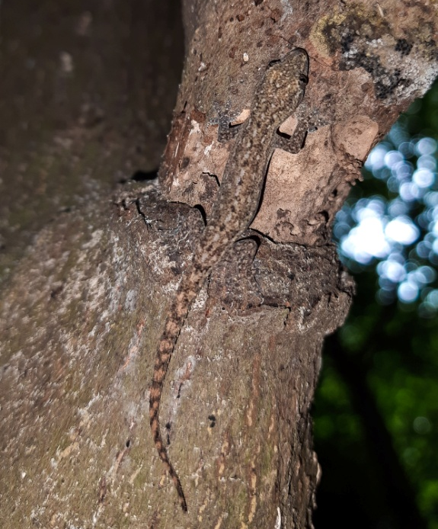
- Gecko species
Hemidactylus sp.
Habitat: Tree
CollectionTime: Noon

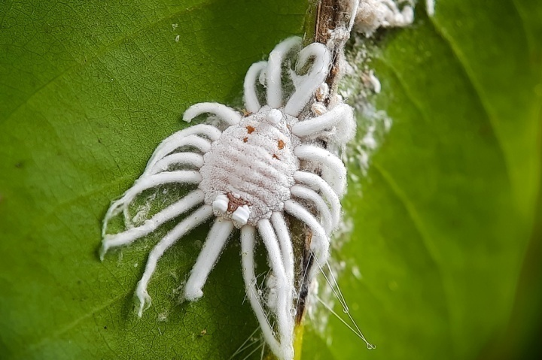

- Scale insect
Icerya sp.
Family: Monophlebidae
Habitat: Foliage
Collection time: Morning

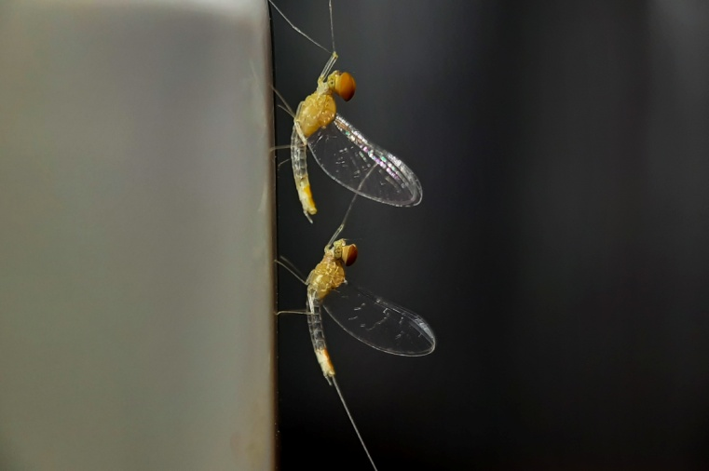

- Mayfly
Order: Ephemeroptera
Habitat: Human habitat
Collection time: Evening

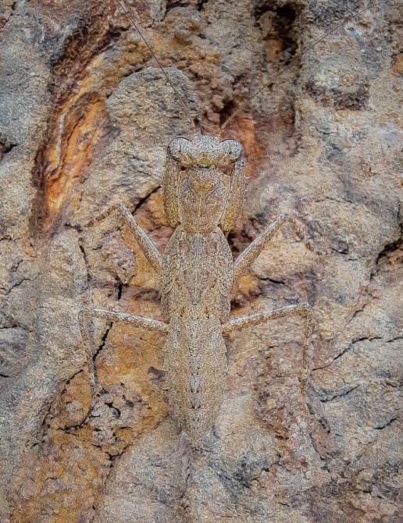

- Bark Mantis
Humbertiella sp.
Family: Gonypetidae
Habitat: Bark of trees
Collection time: Morning

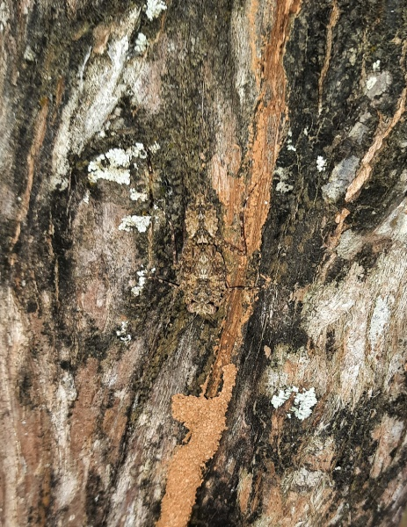

- Indian Bark Mantis
Humbertiella ceylonica (Saussure,1869)
Family: Gonypetidae
Habitat: Bark of trees
Collection Time: Morning

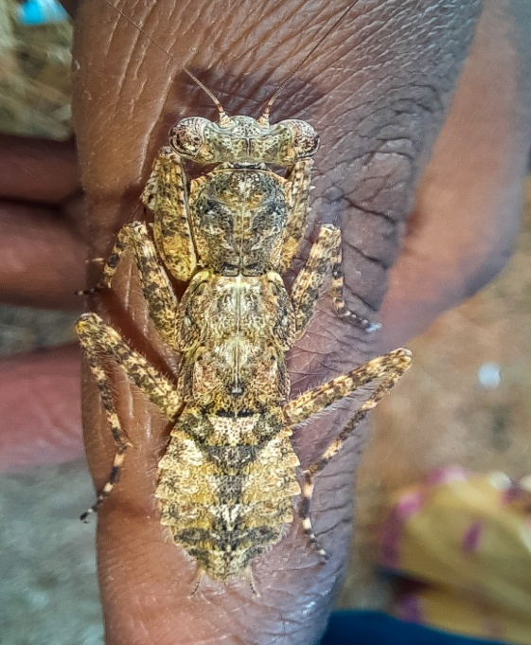

- Lichen Mantis
Gonatista grisea(Fabricius, 1793)
Family: Epaphroditidae
Habitat:Lichen on tree,bark
Collection time: Morning

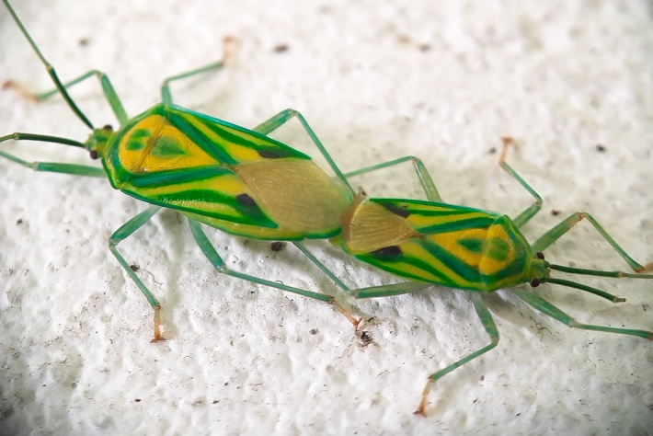
- Green Truebug
Urolabida sp.
Family: Urostylididae
Habitat: Foliage
Collection Time: Morning

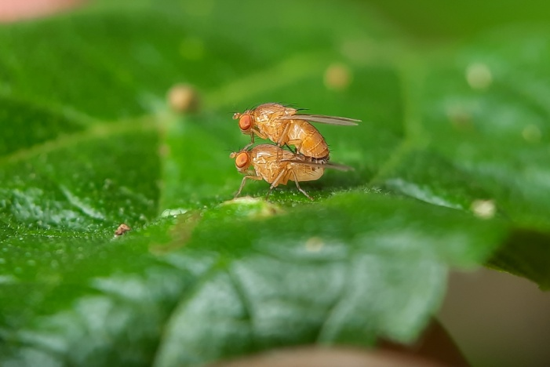

- Fruitfly
Drosophila sp.
Family: Drosophilidae
Habitat: Foliage,bushes
Collection Time: Noon

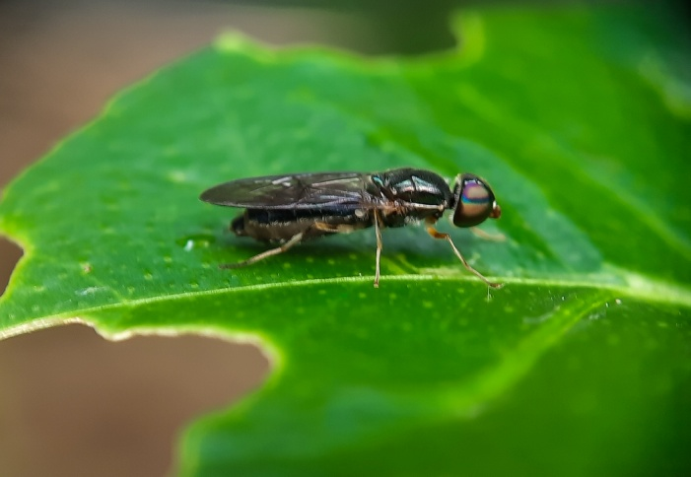

- Soldier Fly
Sargus sp.
Family: Stratiomyidae
Habitat: Rests on trees and bushes
Collection Time: Noon

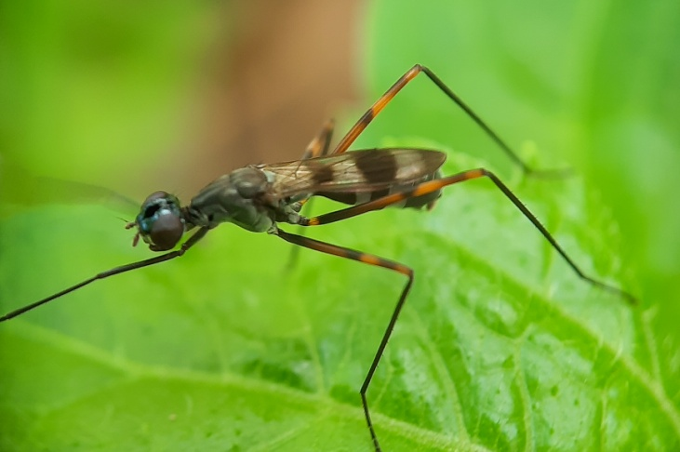
- Stilt-legged fly
Rainineria cf. Calceata
Family: Micropezidae
Habitat : Bushes and scrubs
Collection time: Noon

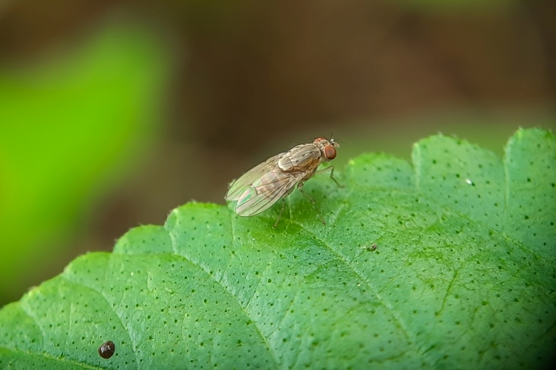

- Acalyptrate Fly
Homoneura sp.
Family: Lauxaniidae
Habitat : Bush
Collection time: Noon

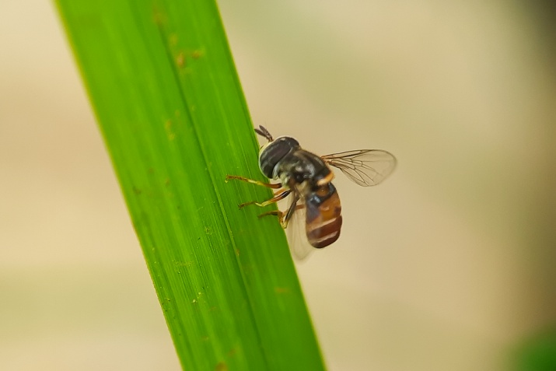

- Hoverfly
Paragus sp.
Family: Syrphidae
Habitat: Bushes
Collection time: Morning

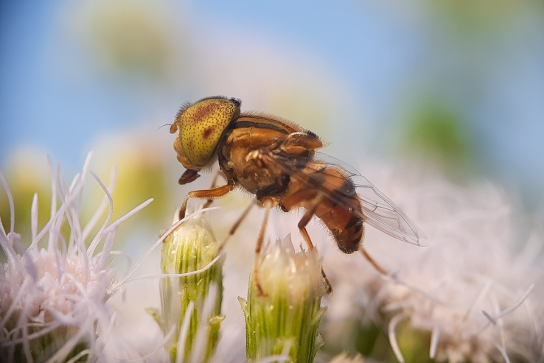
- Drone Fly
Eristalis sp.
Family: Syrphidae
Habitat: Bush and grassland
Collection Time: Noon

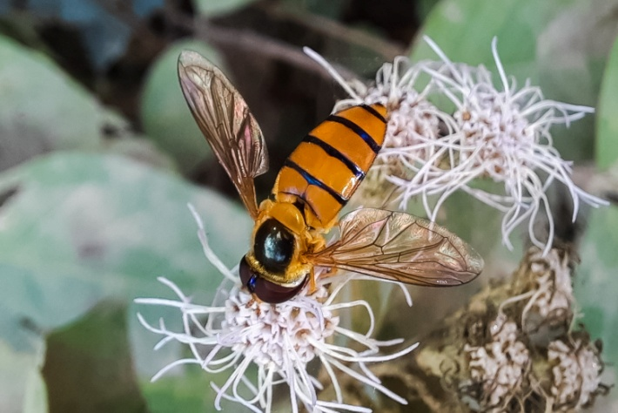

- Hoverfly
Asarkina sp.
Family: Syrphidae
Habitat: Trees and bushes
Collection Time: Morning

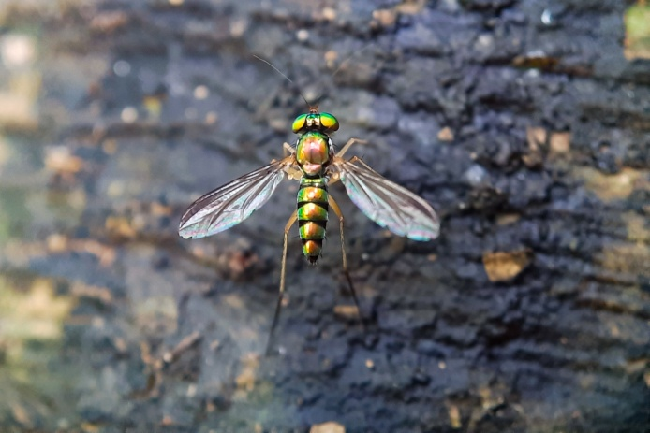

- Long-legged Fly
Condylostylus sp.
Family: Dolichopodidae
Habitat : Bushes and Trees
Collection Time: Noon

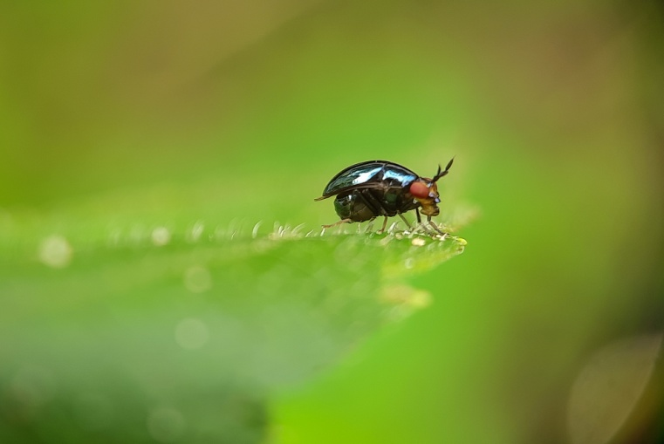
- Beetle-Mimic Fly
Spaniocelyphus sp.
Family: Celyphidae
Habitat: Bush,grasses
Collection Time: Morning

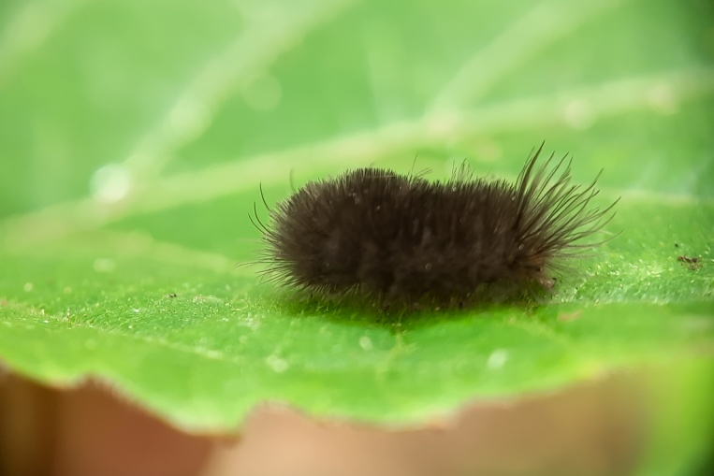

- Tiger Moth
Arctia sp.
Family: Erebidae
Habitat: Trees,shady areas
Collection Time: Morning

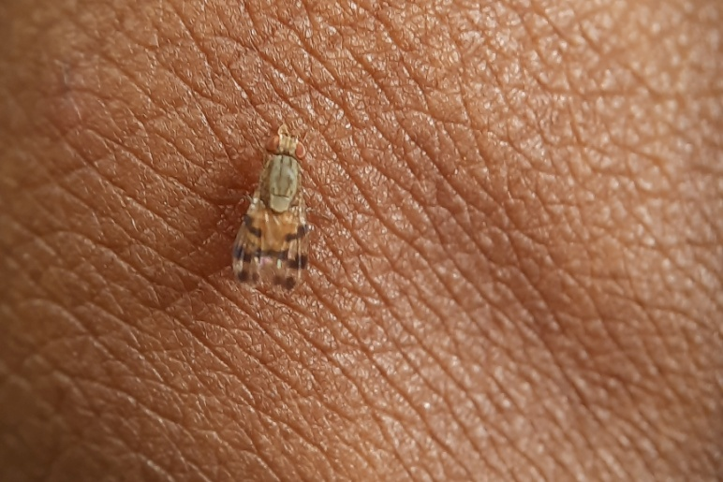

- Acalyptrate Fly
Family: Lauxaniidae
Habitat: Bush
CollectionTime: Morning

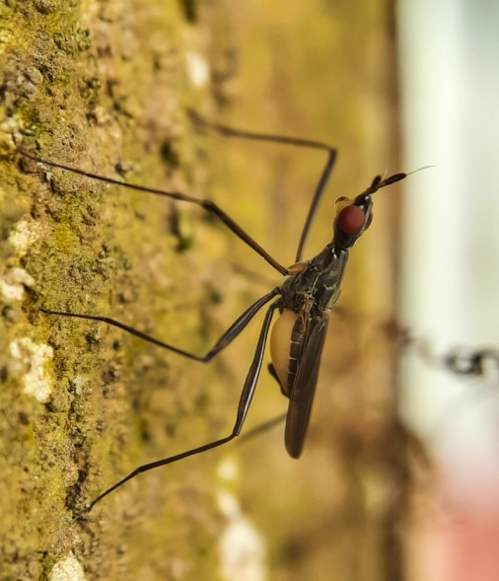
- Banana Stalk-Fly
Family: Neriidae
Habitat: Rests on Tree trunk
Collection time: Noon

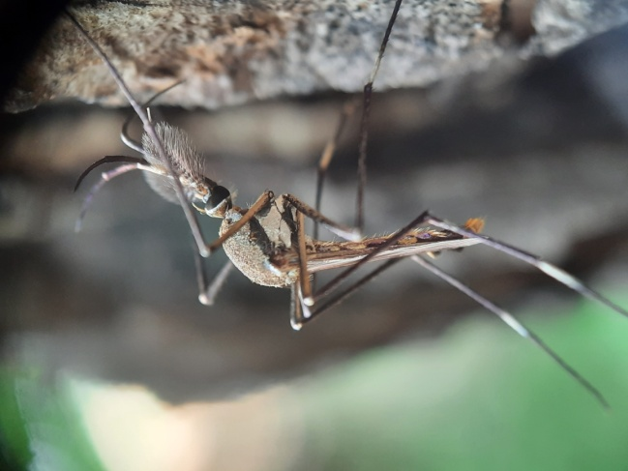
- Elephant Mosquito
Toxorhynchites cf. Splendens
Family: Culicidae
Habitat: Rests on tree trunk
Collection time: Noon

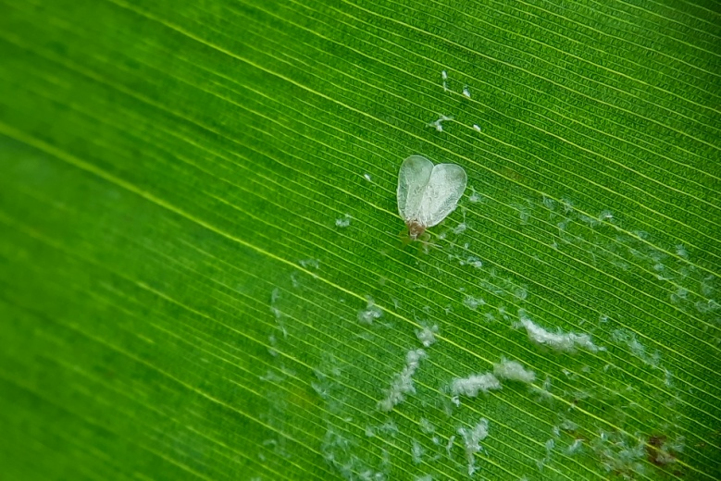

- Whitefly
Family: Aleyrodidae
Habitat: Foliage
Collection Time: Morning

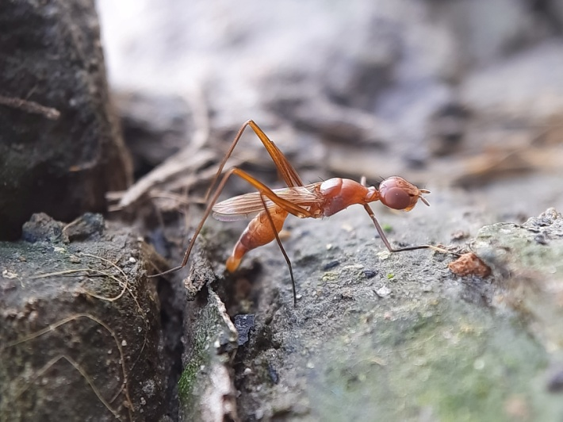
- Weaver Ant mimic Stilt-legged Fly
Famy: Micropezidae
Habitat : Bush and scrubs
Collection Time: Noon

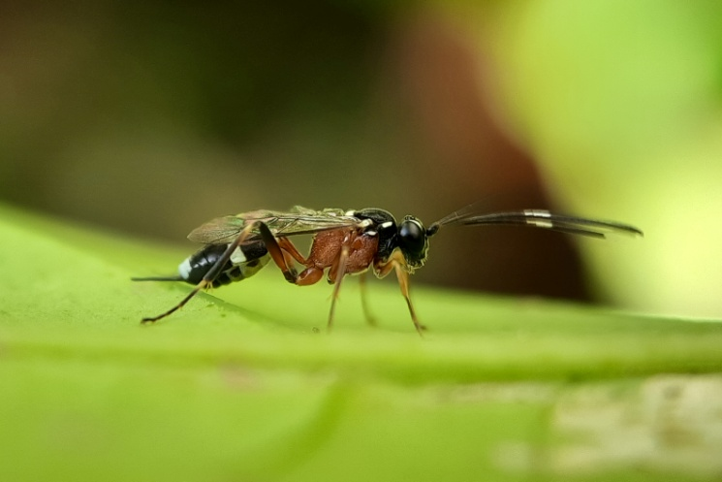

- Ichneumon Wasp.
Family: Ichneumonidae
Sub-Family: Gelinae
Habitat: Bushes and Small plants
Collection Time: Morning

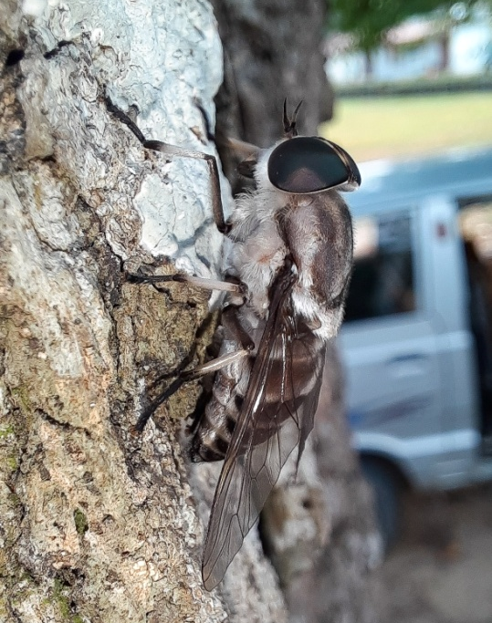

- Horsefly
Tabanus sp.
Family: Tabanidae
Habitat : Tree trunk
Collection Time: Noon

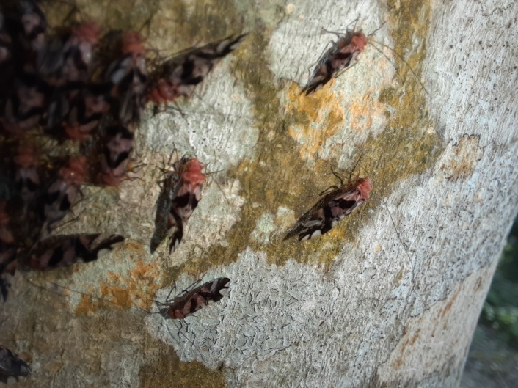
- Barklice
Order: Psocoptera
Habitat : Tree trunk,barks
Collection Time: Morning

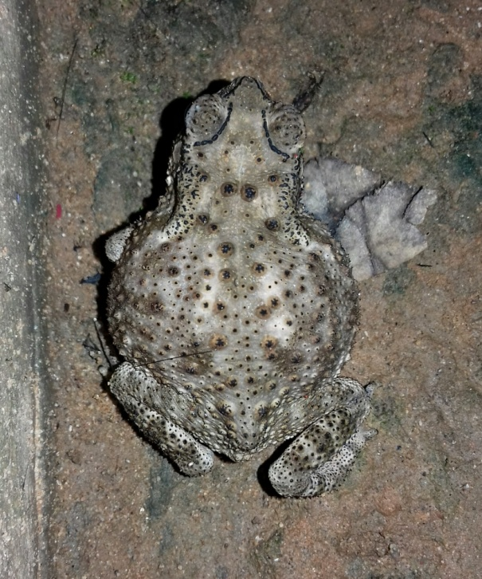

- Asian Common Toad
Duttaphrynus melanostictus (Schneider,1799)
Family: Bufonidae
Habitat: Wet place,Water drained areas
Collection Time: Noon

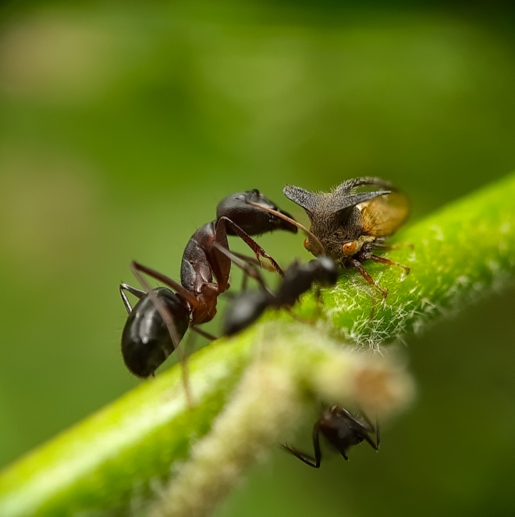

- Thorn mimic Treehopper
cf. Leptocentrus sp.
Family: Membracidae
Habitat : Trees and plants
Collection Time: Morning

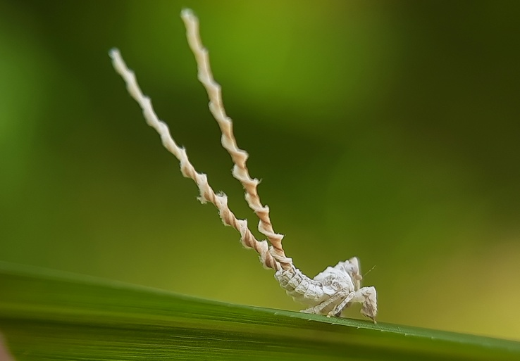
- Wattle Hopper
cf. Olonia sp.
Family: Eurybrachidae
Habitat: Grasses
Collection Time: Afternoon

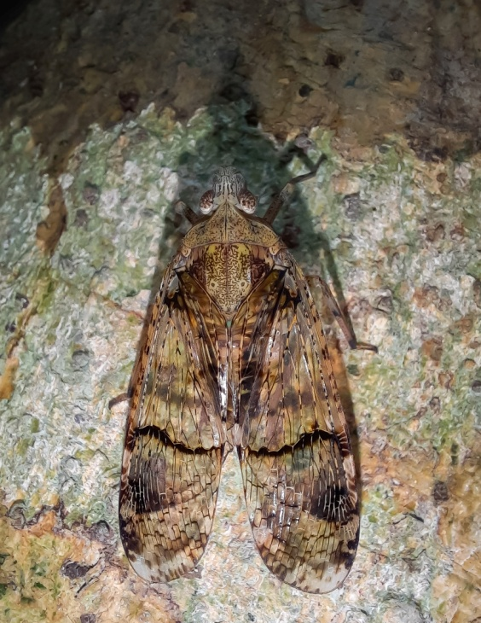

- Planthopper
Dichoptera sp.
Family: Fulogridae
Habitat :crevices of Big trees
Collection Time: Morning

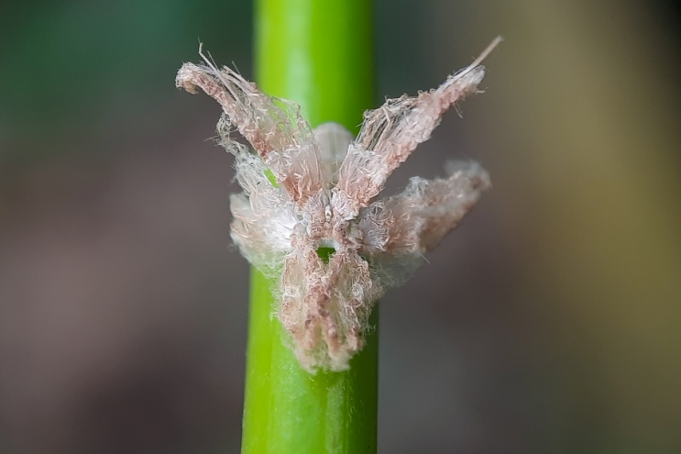

- Fulgorid planthopper
Family: Flatidae
Habitat: Bushes
Collection Time: Morning

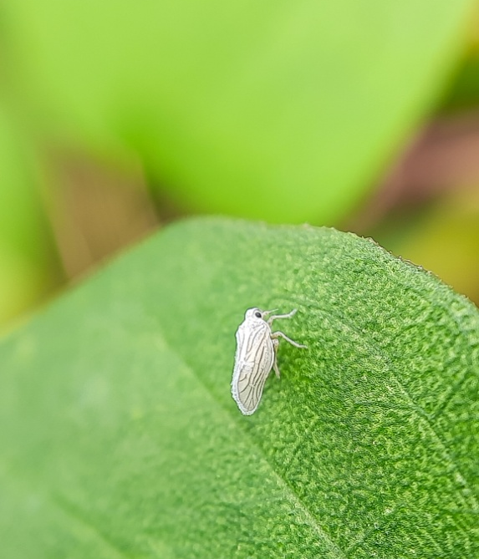
- Leafhopper
Typhlocyba sp.
Family: Cicadellidae
Habitat: Bushes
Collection time: Noon

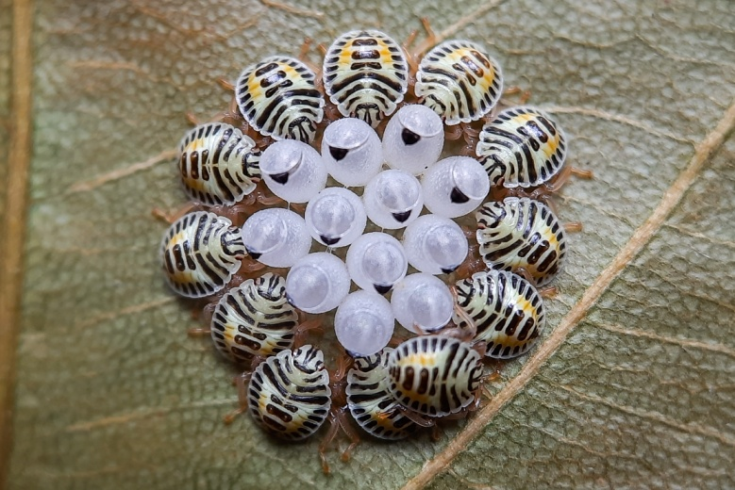

- Stink Bug
Family: Pentatomidae
Sub-Family: Asopinae
Habitat :Foliage
Collection Time: Morning

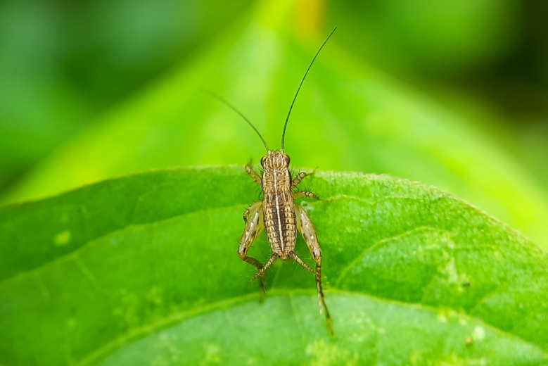

- Cricket
Xenogryllus sp.
Family: Gryliidae
Habitat :bush
Collection time: Morning

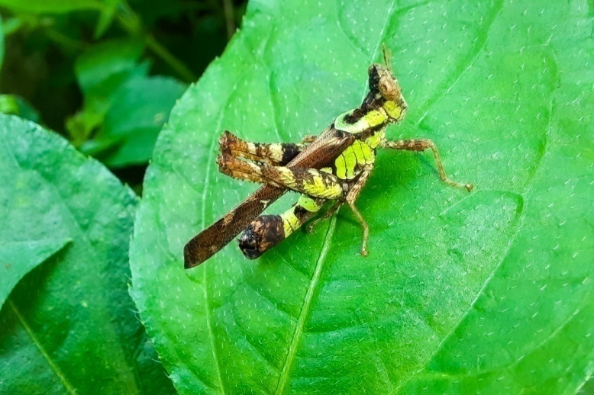
- Monkey Grasshopper
Erianthus sp.
Family: Chorotypidae
Sub-Family: Erianthinae
Habitat: Bush
Collection: Noon

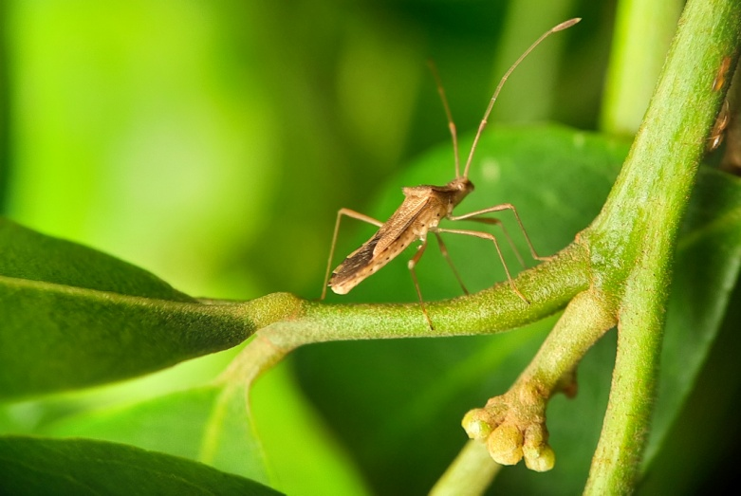

- Rice Earbug
Leptocorisa oratoria (Fabricius, 1794)
Family: Alydidae
Habitat: Foliage
Collection Time: Noon

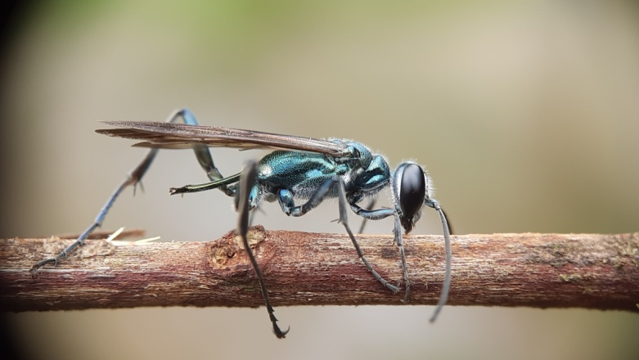

- Oriental Blue Mud Dauber Wasp
Chalybion bengalense (Dahlbom,1845)
Family: Sphecidae
Habitat: Ground
Collection Time: Morning

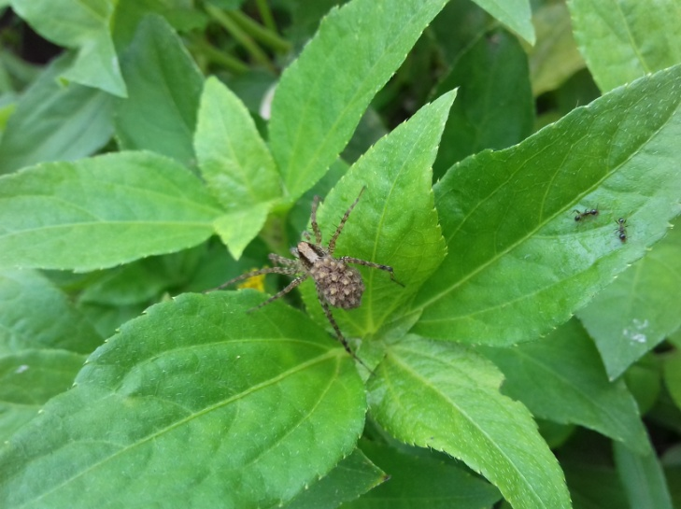
- Wolf Spider
Pardosa sp.
Family: Lycosidae
Habitat:Ground
Collection time: Noon

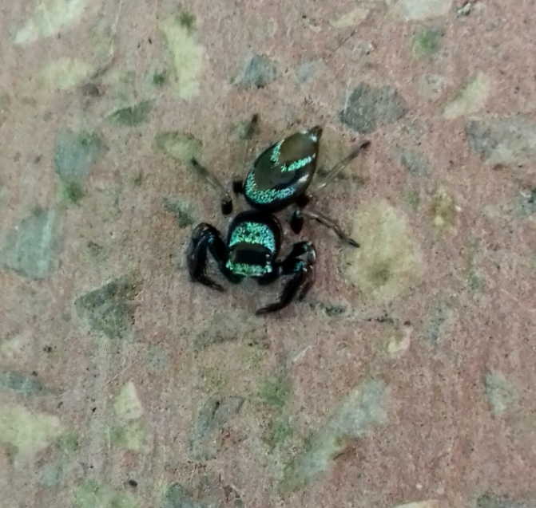

- Fighting Spider
Thianiabhamoensis(Thorell,1887)
Family: Salticidae
Habitat: Foliage
Collection Time: Noon

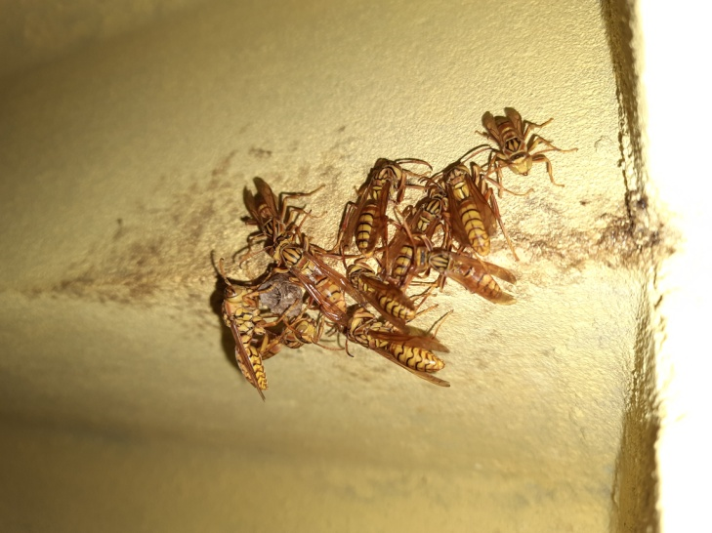

- Paper Wasp
Polistes sp.
Family: Vespidae
Tribe: Polistine
Habitat : Bushes and trees
Collection Time: Noon

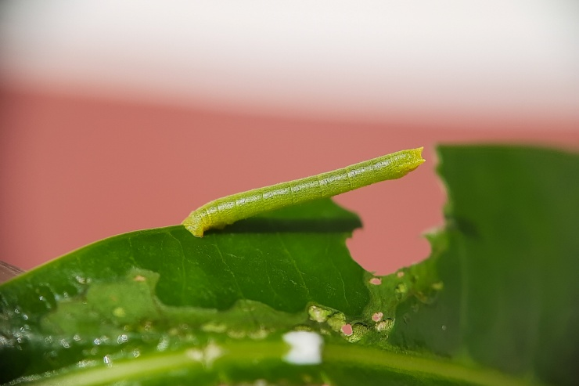

- cf. Parotis sp.
Family: Crambidae
Tribe: Margaroniini
Habitat :Foliage
Collection Time: Morning

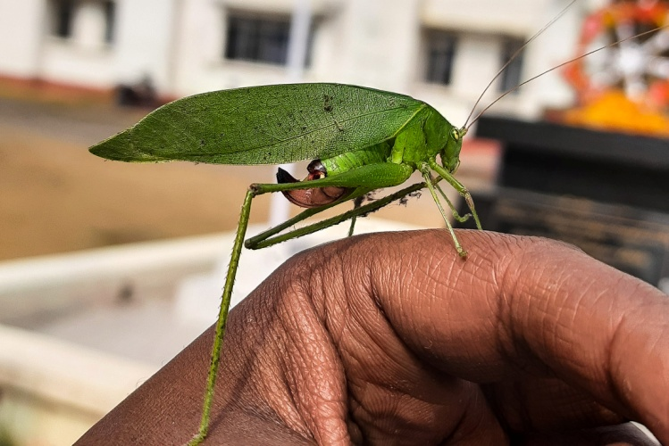

- Katydid
Trigonocorypha sp.
Family: Tettigoniidae
Habitat: bushes
CollectionTime: Morning

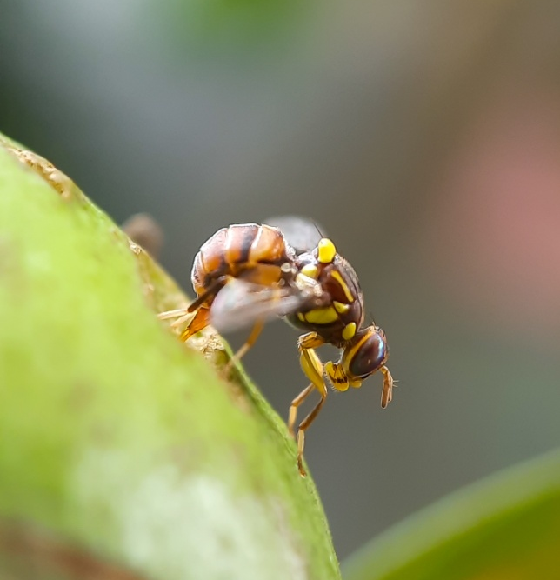

- Fruit Fly
Bactrocera sp.
Family: Tephritidae
Habitat: Fruit trees
Collection Time: Noon

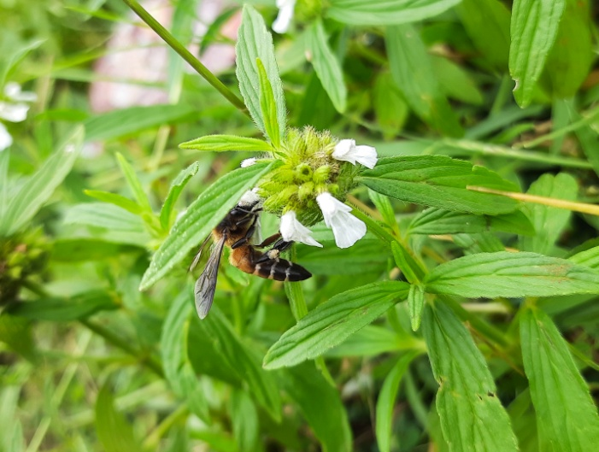
- Honey bee
Apis sp.
Family: Apidae
Habitat: Gardens
Collection Time: Morning

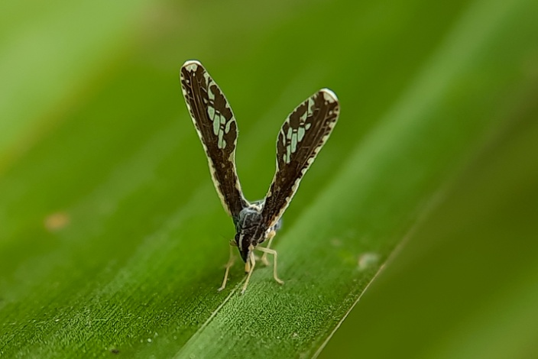

- Derbid Planthopper
Proutistamoesta(Westwood,1851)
Family: Derbidae
Habitat : FoliageCollection Time:noon

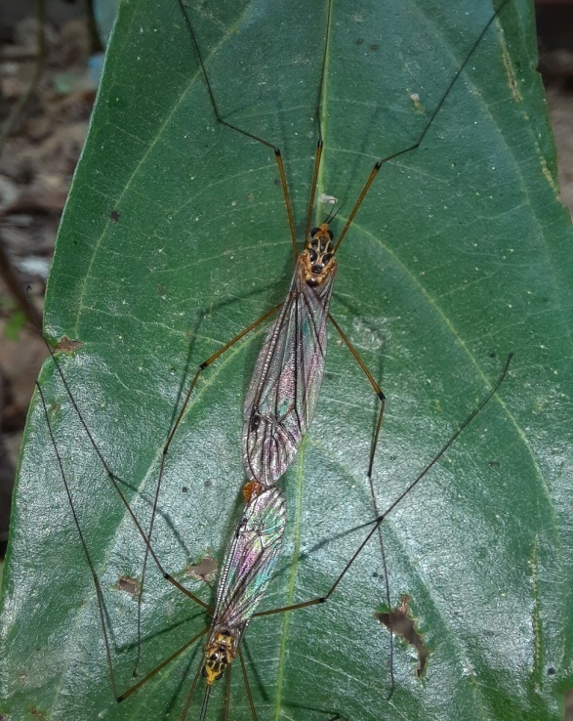

- Crane fly
Nephrotoma cf. Cornicina
Family: Tipulidae
Habitat:Foliage
Collection time: Noon

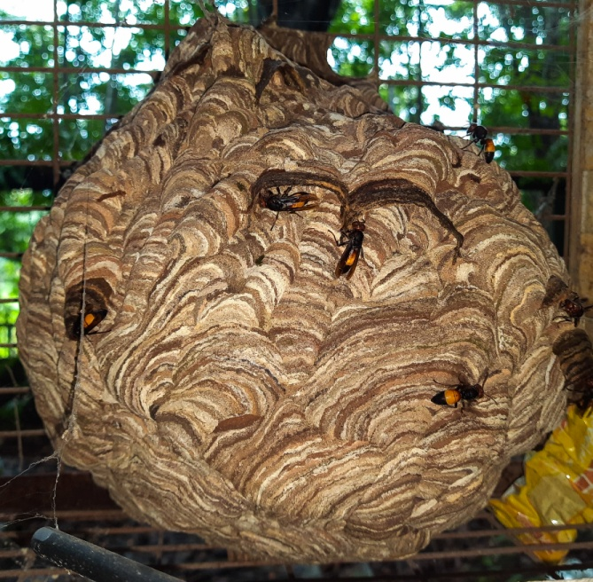
- Lesser banded Hornet
Vespa affinis(Linnaeus,1764)
Family: Vespidae
Habitat:Dark shady place without disturbance
Collection Time:Morning

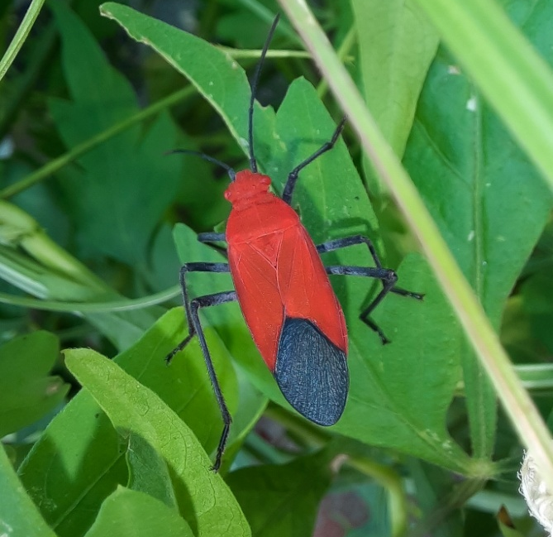

- Soapberry bug
Leptocoris augur (Fabricius,1781)
Family: Rhopalidae
Habitat : GreenBushes
Collection Time: Noon

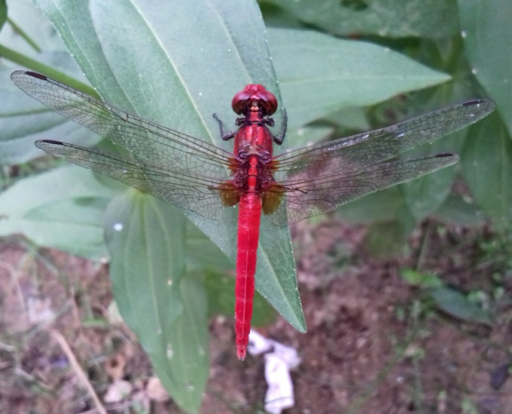

- Ruddy marsh skimmer
Crocothemis servilia(Drury,1773)
Family: Libellulidae
Habitat: Open lands
Collection time: Morning

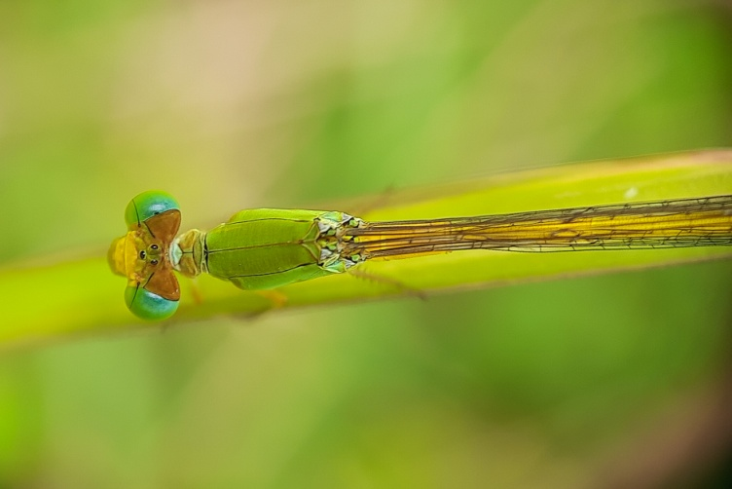
- Coromandel Marsh Dart
Ceriagrion coromandelianum (Fabricius,1798)
Family: Coenagrionidae
Habitat : Grassland
Collection Time: Noon

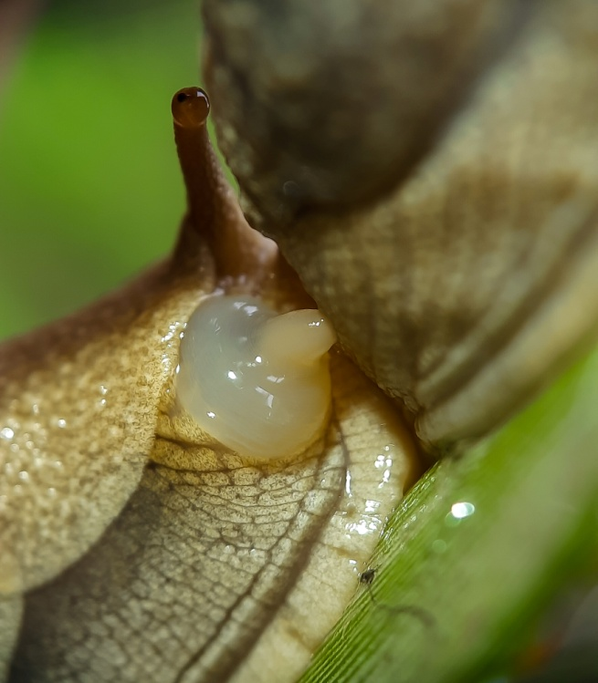

- Grey Garden slug
Deroceras reticulatum ( O.F.Müller,1774)
Family: Agriolimacidae
Habitat: Wet places
Collection time: Noon

