REPORT A CULTURAL PROGRAME ON THE CELEBRATION OF 161 BIRTHDAY OF KABI GURU RABINDRANATH TAGORE : ON 21/05/2022

ORGANIZED BY THE DEPARTMENT OF BENGALI NSM. UDAIPUR. GOMATI TRIPURA.

The Department of Bengall, N.S.M Udaipur, Gomati Tripura had organized. a seminar/ discussion on RabindraNath Tagore to honor the Kabi Guru. Socia and Academic Reformer, pride of Bengal.
The Head of the Department, Dr. Shankari Das introduced the great personality and literature. Resource person Dr. Nirmal Das, Asst. professor. Bengali Department Tripura University had delivered his paper name – “ Banger Renesa Rabindranath o samakalin Manus.”

Faculty members of various Departments, and The Secretary Teacher's council, teachers of the department delivered their speeches to pay their humble respect for the great soul.
The programme was chaired by the principal who spoke about the relevance of Rabndra lterature. The Saminar was attended by about 106 Students and faculty members.

NETAJI SUBHASH MAHAVIDYALAYA
GOMATI, UDAIPUR, TRIPURA
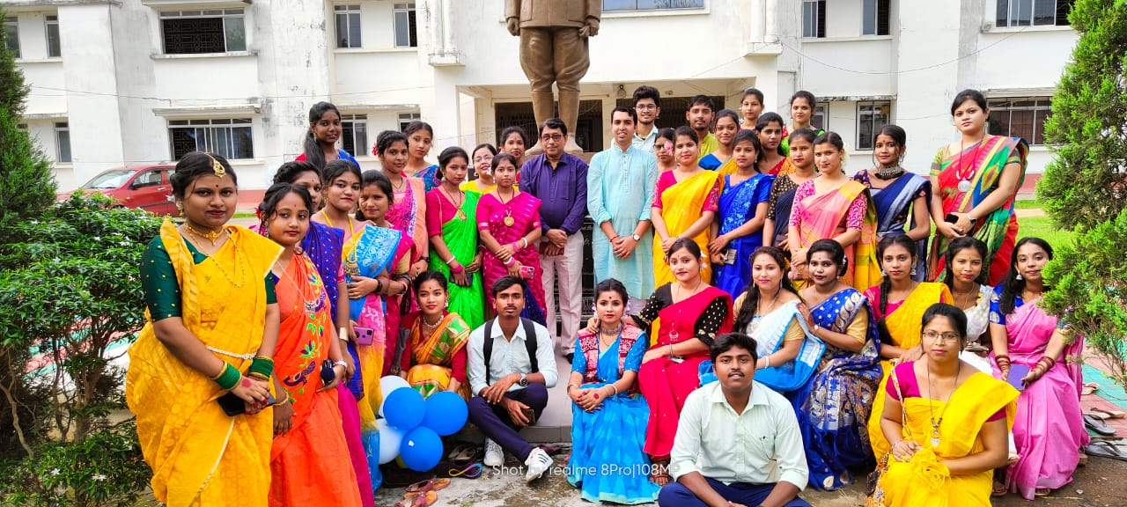

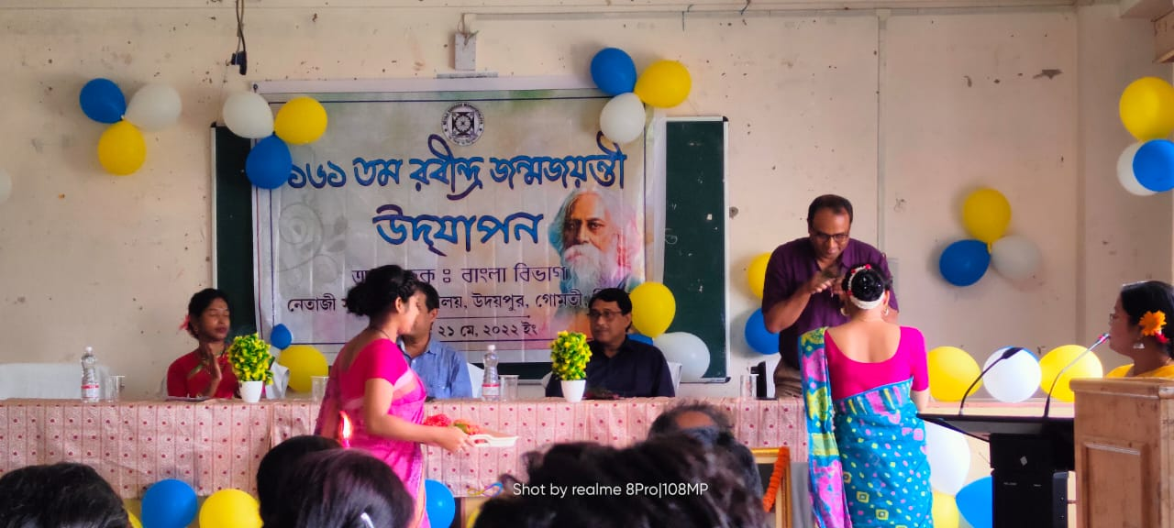

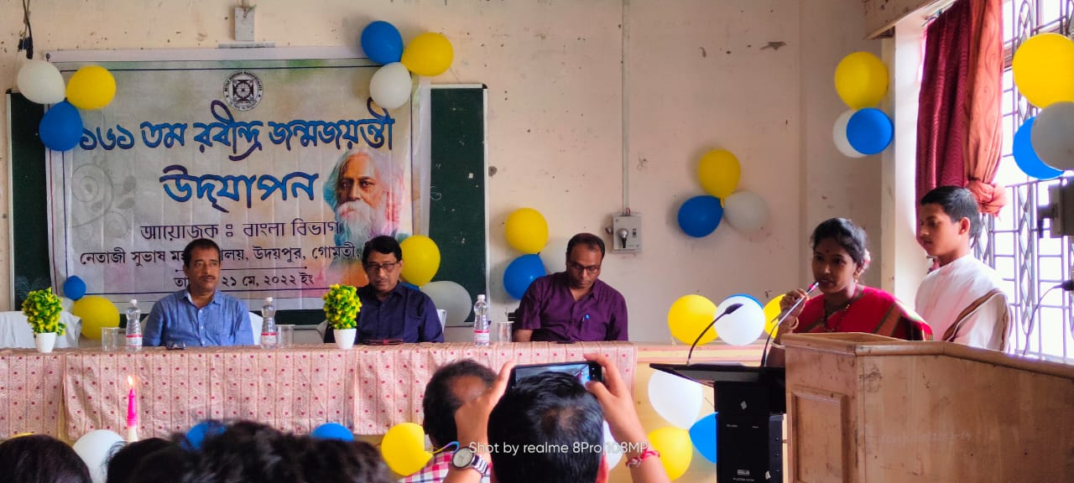

NETAJI SUBHASH MAHAVIDYALAYA
GOMATI, UDAIPUR, TRIPURA
